# CHAPTER 6

## ISOMETRIC PROJECTION

##### Problem 1 A sphere of diameter 50 mm rests centrally on top of a cube of sides 50 mm. Draw the lsomet-

ric projections of the combination of solids.

##### Solution

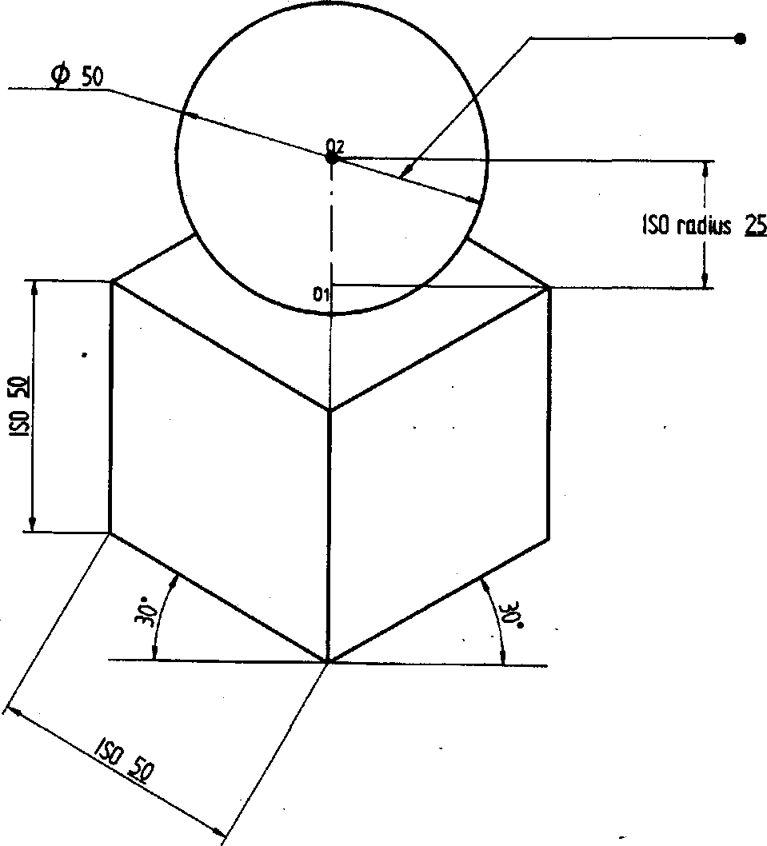

TkflE kBl8S OF 50

Problem 2 A hemisphere of 40 mm diameter is supported co-axially on the vertex of a cone of base dia. 60 mm and axis length 50 mm. The flat circular face of the hemisphere is facing upside. Draw the isometric projection of the combination of solids.

##### Solution

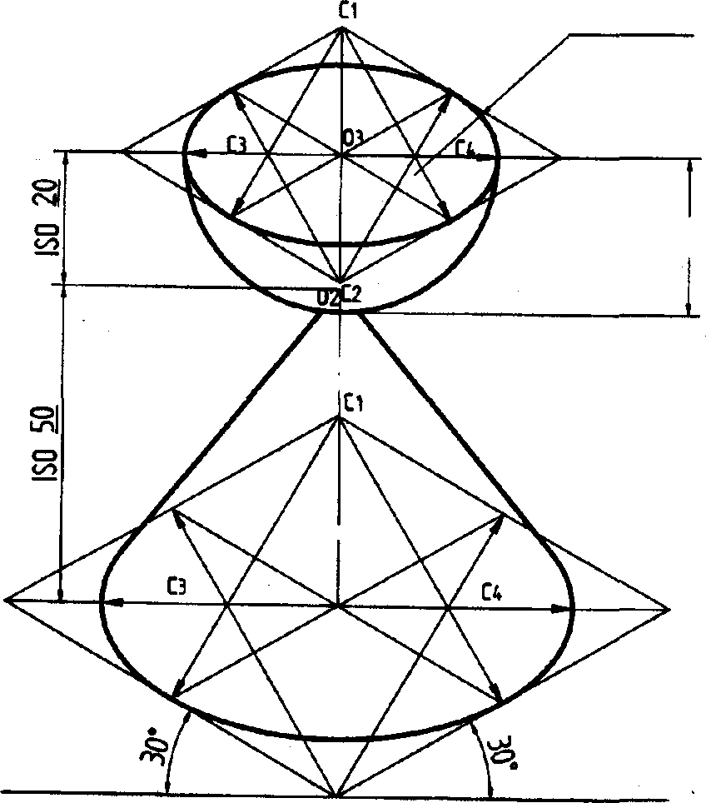lt0 &20

Actual radius 20

C2

oblem 3 Draw the lsometric projection of a rectangular prism of 60 x 80 x 20 mm thick surmounting a etrahedron of sides 45 mm such that the axes of the solids are. collinear and at least one of the edges of both the solids are parallel to VP. Solved examples 6.1 p140, 6.2 p143, 6.3 p146, 6.4 p150 and 6.5 p156 of primer Solution

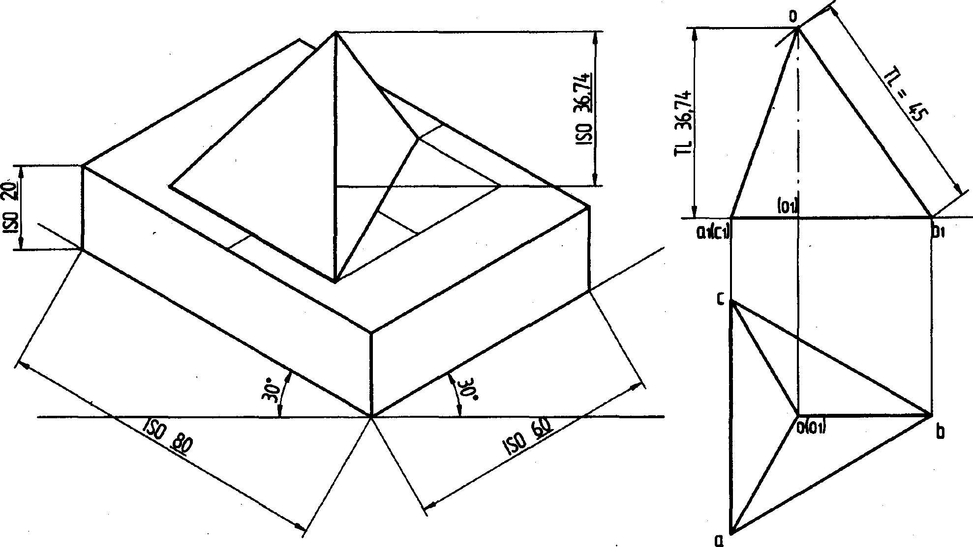

##### a

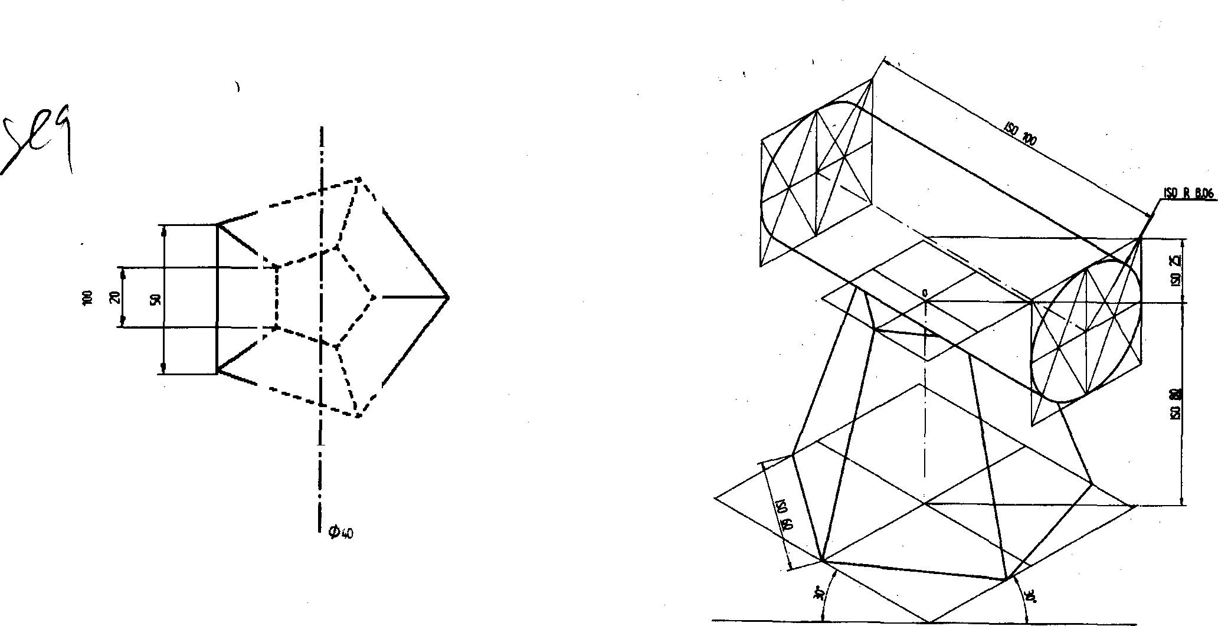

Problem 4 Following figure shows the top view of a cylinder which is centrally mounted on a frustum of pentago @›f 60 mm height. Draw the Isometric projection of the combination of solids.

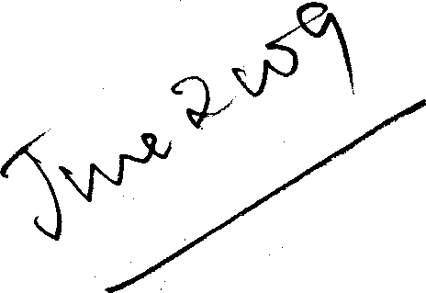Problem S Following figure shows the front view of combination of solids consisting a cut sphere and frustums of a cone and a square pyramid. Drpw the Isometric projection oS the combination of solids.

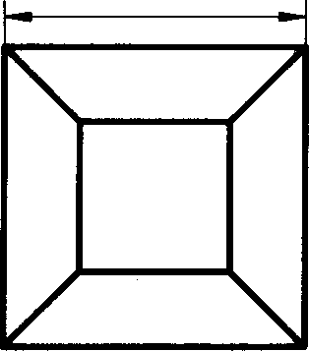

*0* 40

0 60

# Solution

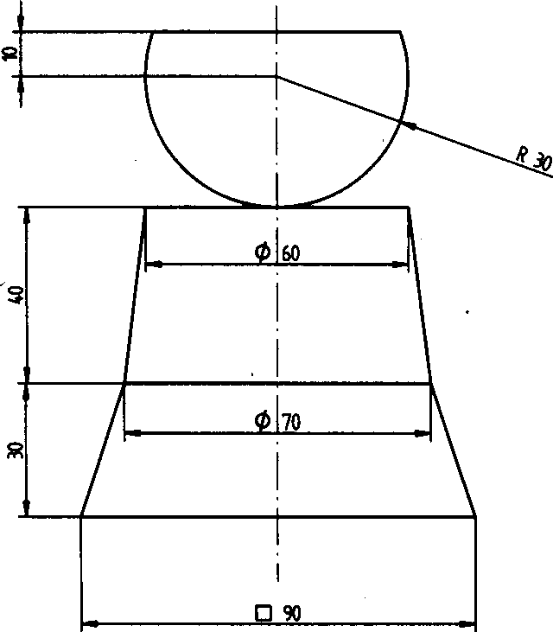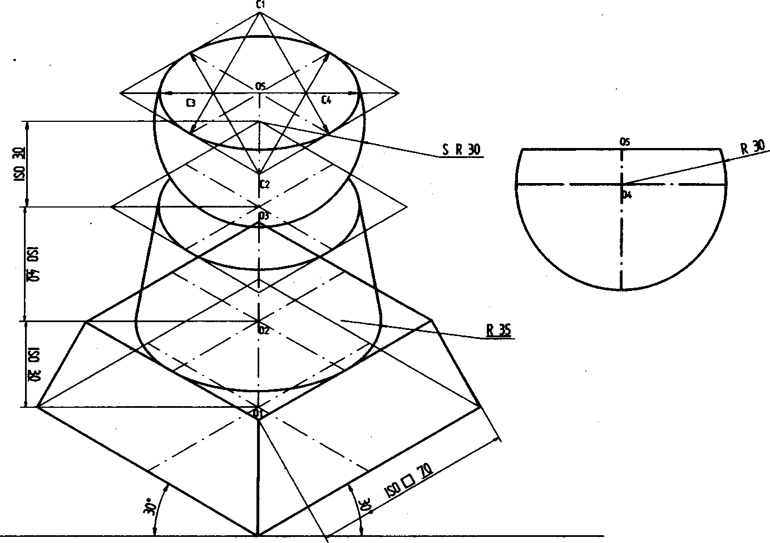

Problem 6 The frustum of a square pyramid of sides 40mm and height 60mm rest on the centre of the top of a square block of side 60mm and height 20mm. The base edges of the pyramid are parallel to the top edges of the square block. Draw the isometric projection of the combination of the solids.

### Solution

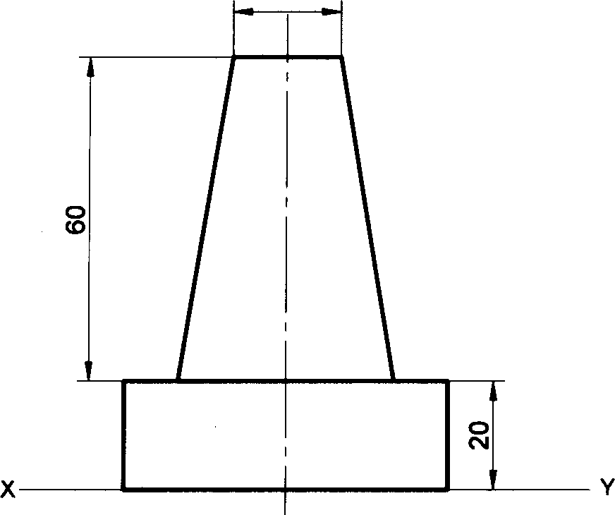

EJ 20

VP

HP

Problem 7 A square pyramid of base side 40mm and height 70mm rests symmetrically on a cube of edge 50mm, which itself is placed on a cylinder of diameter 80mm and thickness 30mm. Draw the isometric projection of the solids, if the axes of the three solids are in common line.

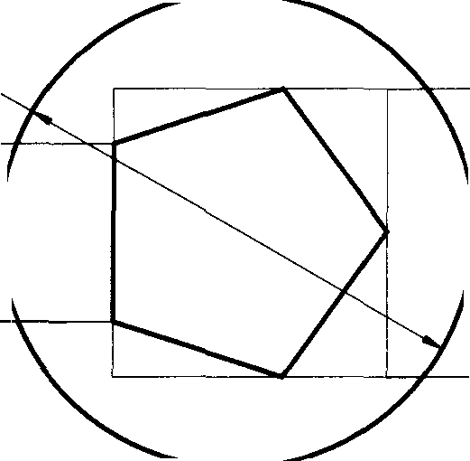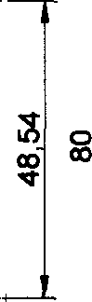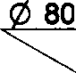

### Solution

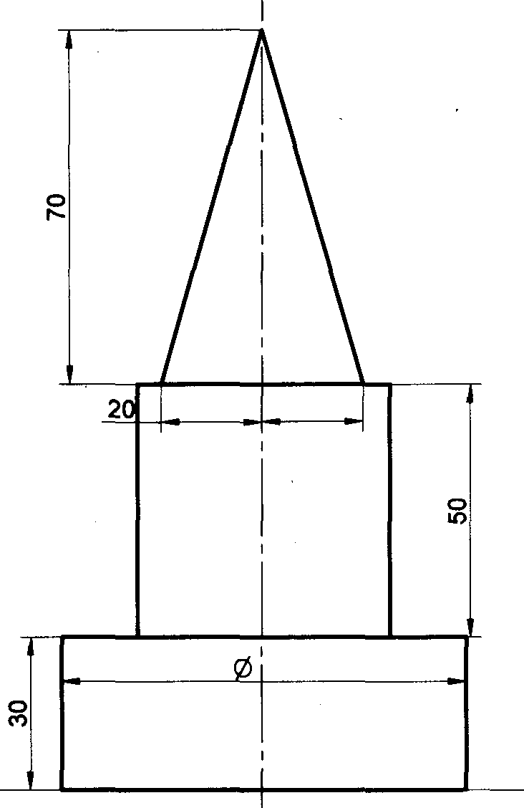

20

80

##### Problem 8 A regular pentagonal prism of base edge 30mm and axis 60mm is mounted centrally over a cylindrical

block of 80mm diameter and 25mm thick. Draw isometric projection of the combined solids.

##### Solution

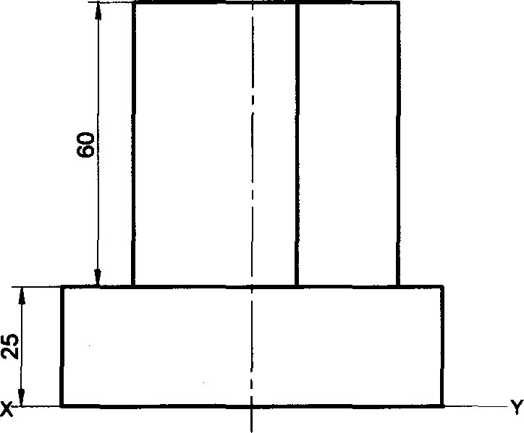

VP

HP

Problem 9 A sphere of diameter 30mm rests on the frustum of a hexagonal pyramid base 30mm, top face 18mm

30

##### side and height 50mm, such that their axes coincide. Draw the isometric projection of the combined solids. Solution

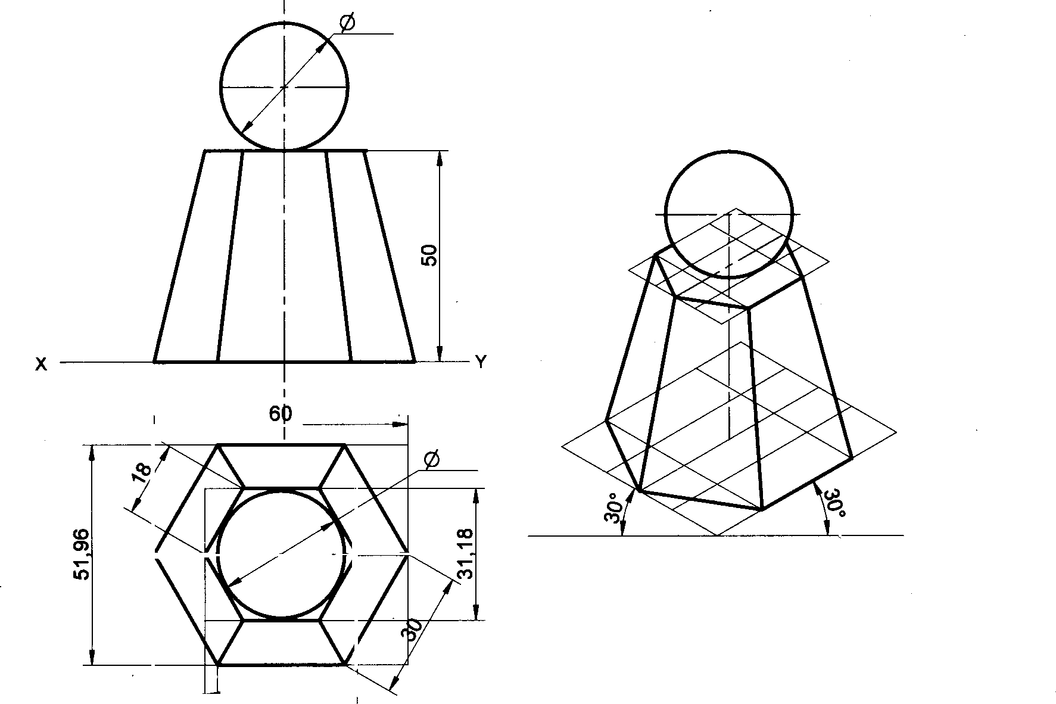

30

VP

HP

30

15

30

Problem 10 A pentagonal pyramid of base side 30mm and axis length 60mm is resting on HP on its base with a side of base perpendicular to VP. Draw its isometric projections

##### Solution

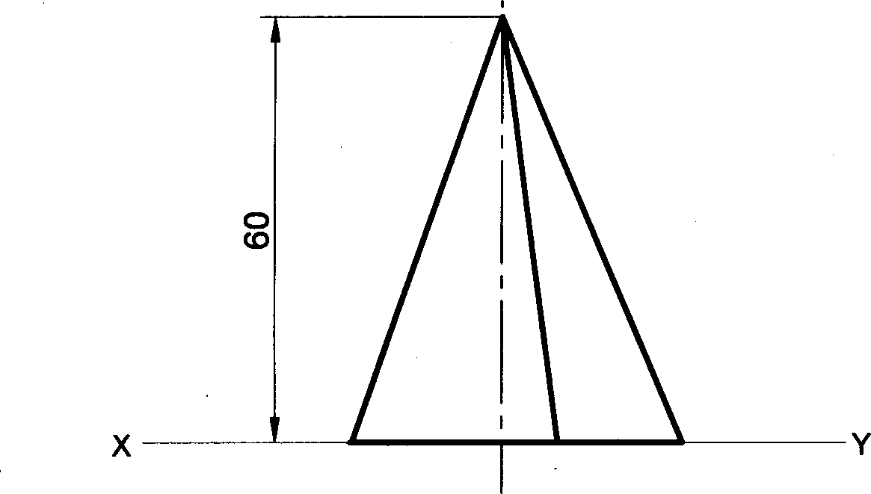

VP

HP

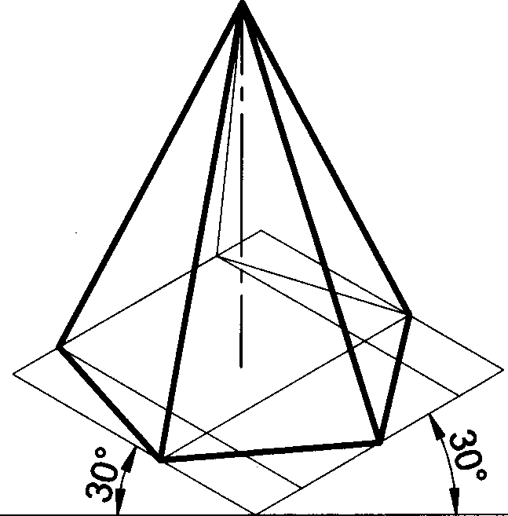

Problem 11 Draw isometric projection of a hexagonal prism of side of base 40mm and height 60mm with a right circular cone of base 40mm as diameter and altitude 50mm, resting on its top such that the axes of both the solids are collinear.

##### Solution

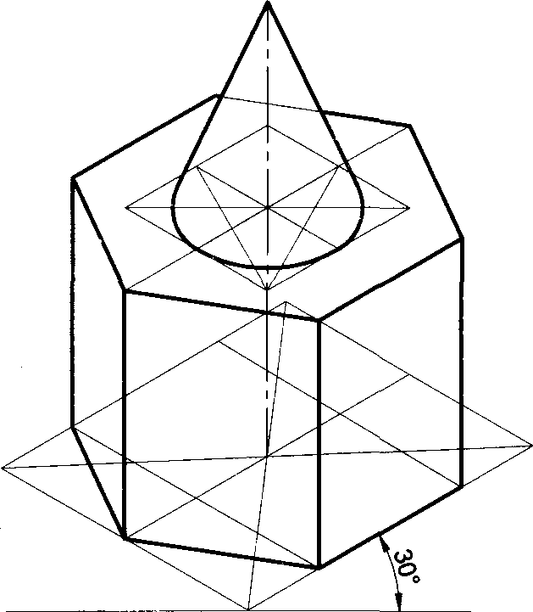

Problem 12 A cone of base diameter 30mm and height 40mm rests centrally over a cube of side 50mm. Draw the

isometric projection of the combination of solids

##### Solution

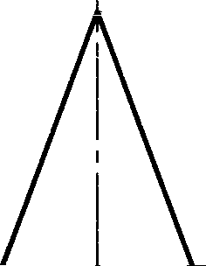

VP

HP

40

X

50

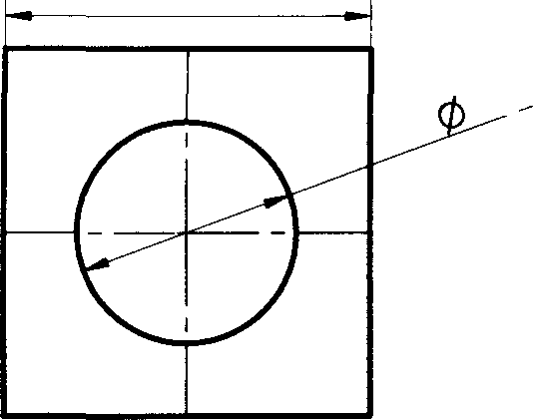

0 50

Problem 13 A cone of base diameter 40mm and height 50mm rests centrally over a frustum of a pentagonal pyramid of base side 45mm and top side 35mm and height 55mm. Draw isometric projections of the solids.

##### Solution

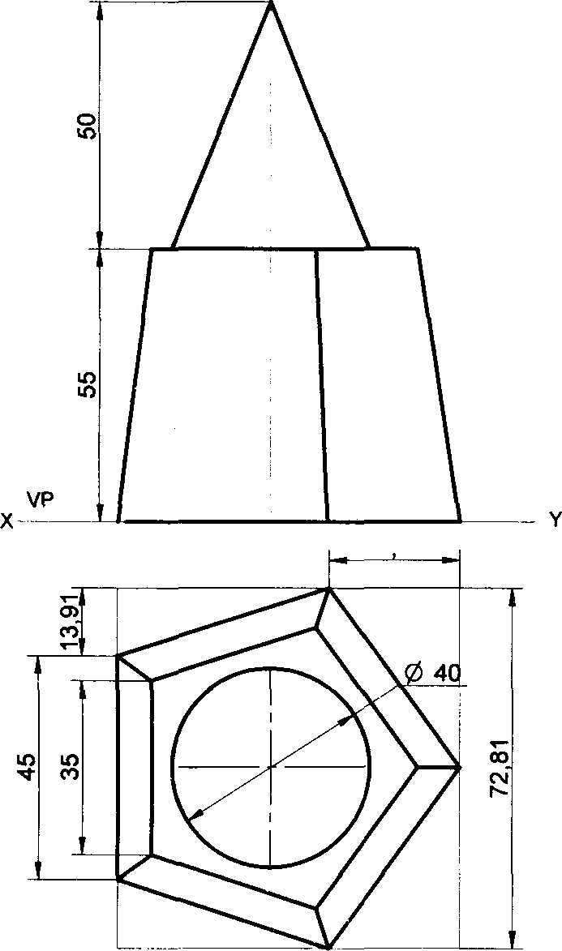

HP

26 45

Problem 14 A sphere of diameter 45mm rests centrally over a frustum of cone of base diameter 60mm, top diameter 40mm and height 60mm. Draw its isometric projections.

##### Solution

45

VP



X - Y

HP

40

@ 60

Problem 15 A hemisphere of diameter 50mm is centrally resting on top of a square prism of base side 60mm and height 30mm such that the curved surface of hemisphere is touching the top face of the prism. Draw its isometric

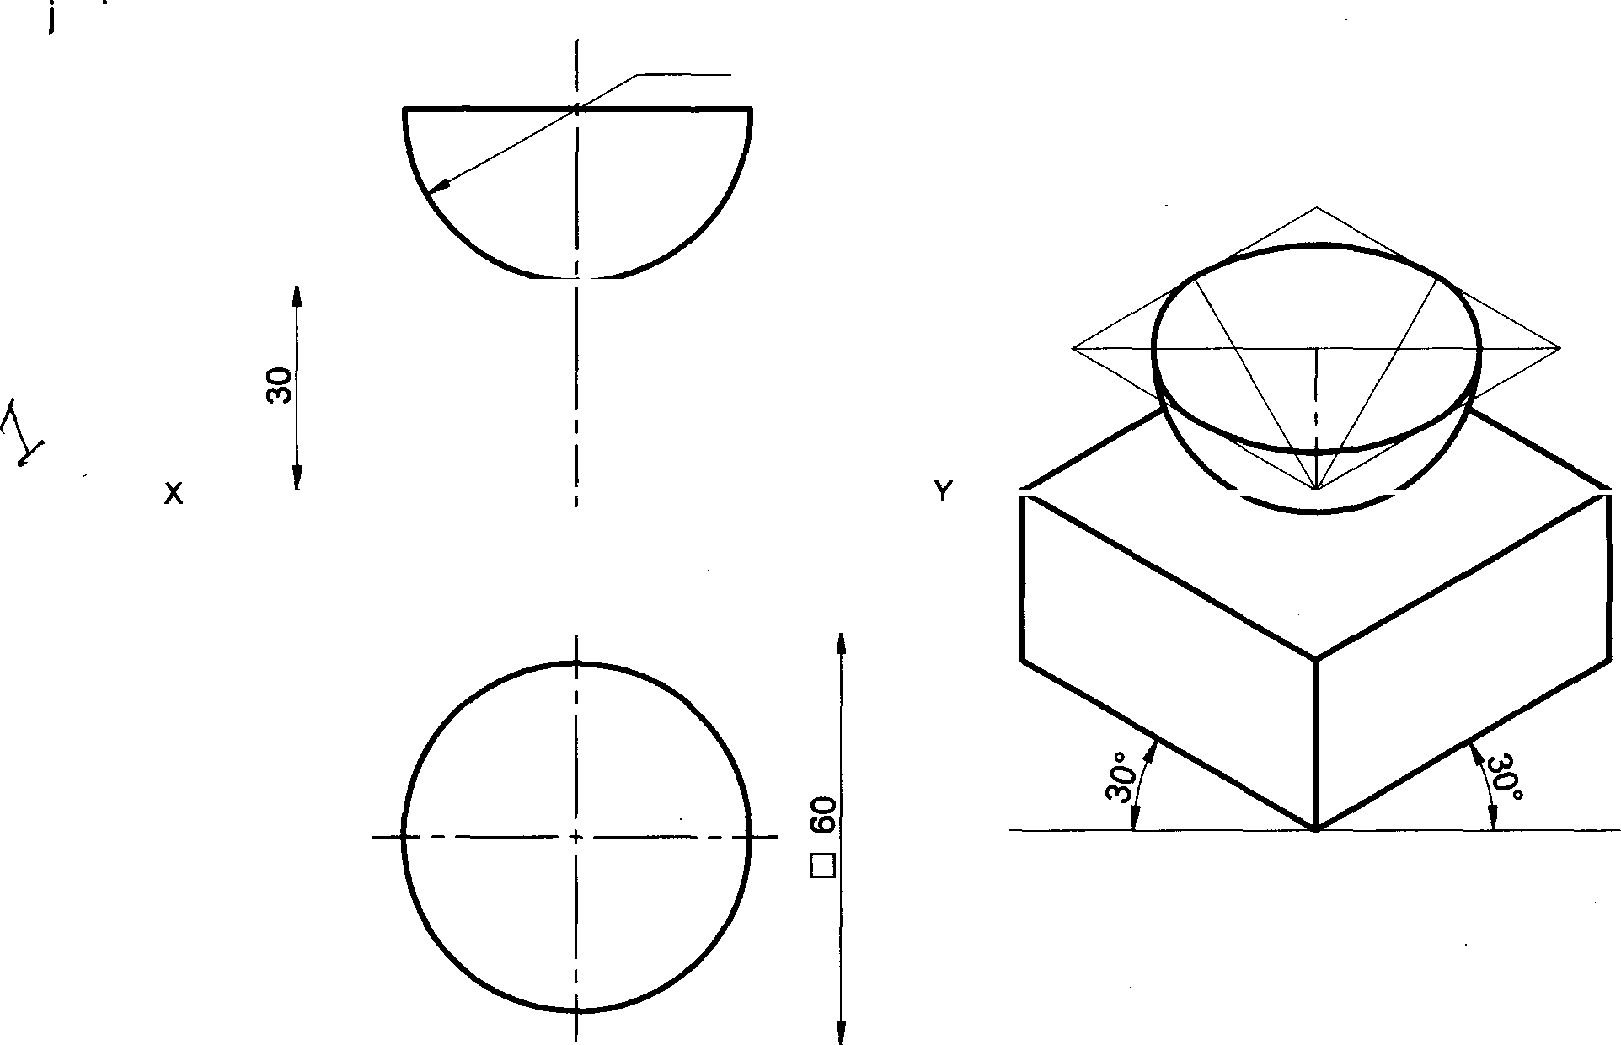

pro ections

Solution

R 25

VP

HP

Problem 16 Draw the isometric projection of the combination of solids formed by a frustum of cone and co-axial frustum of pentagonal pyramid. The lower frustum of cone is of 80mm base diameter, 60mm top diameter and height 25mm. the upper frustum of pyramid is of 30mm side of base, 20mm side of top face and height 40mm.

##### Solution

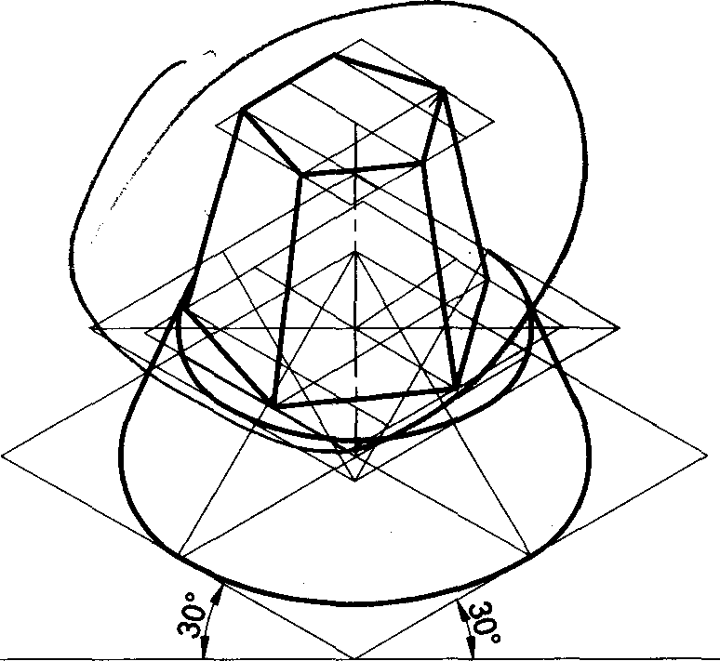 

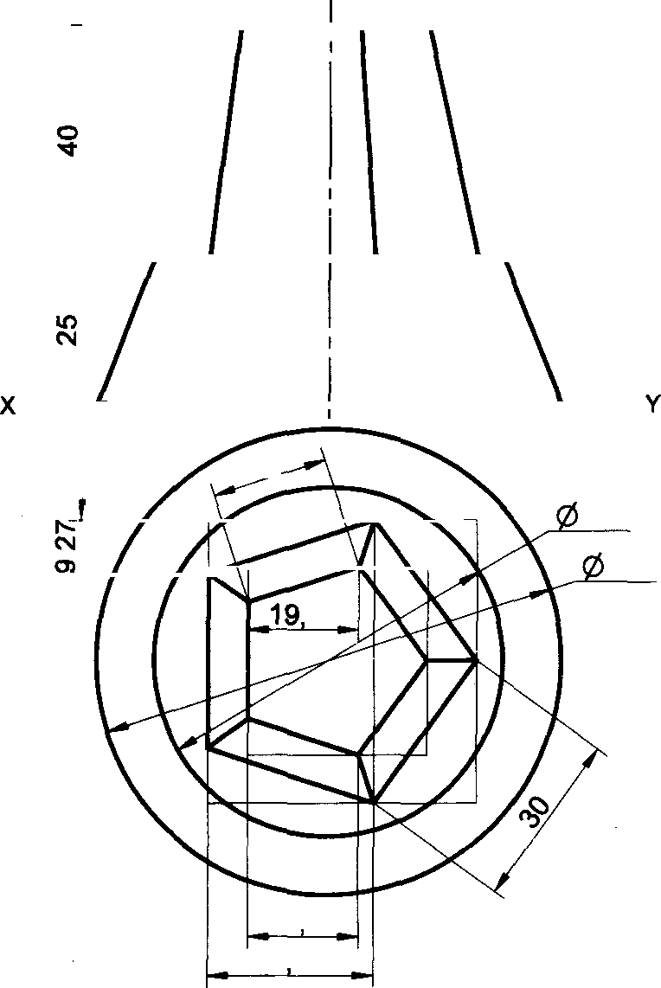

VP

HP

60

80

02

1902

28 53

##### 158

Problem 17 A cone of base diameter 50mm and height 40mm is placed centrally on the top face of a square slab side-80mm and height20mm. Draw the isometric projection of the combination

30

Solution

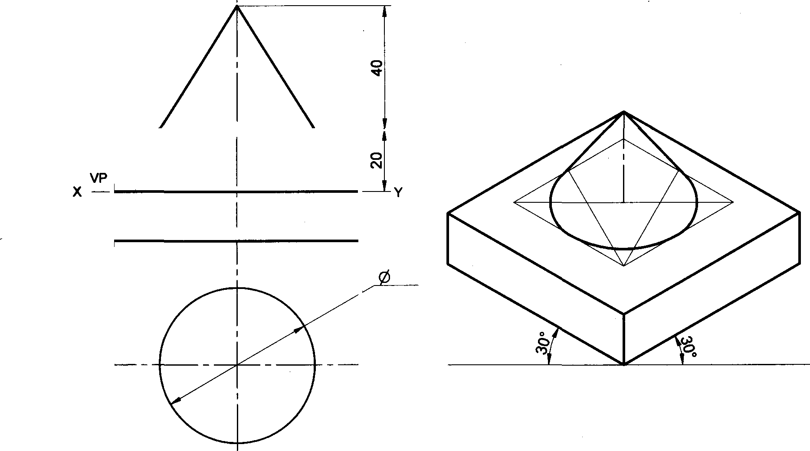

HP

50

0 80

##### Problem 18 A rectangular pyramid of base-40mmx25mm and height 50mm is placed centrally on a cylindrical slab of diameter 100mm and thickness-30mm. Draw the isometric projection of the combination

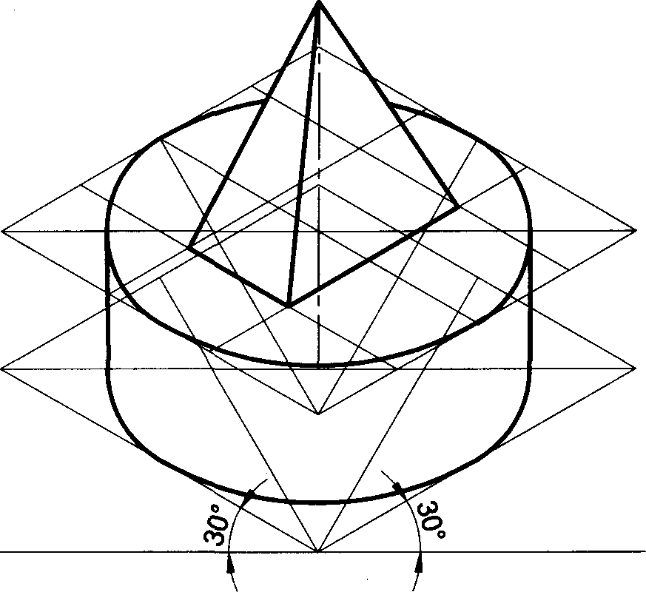Solution

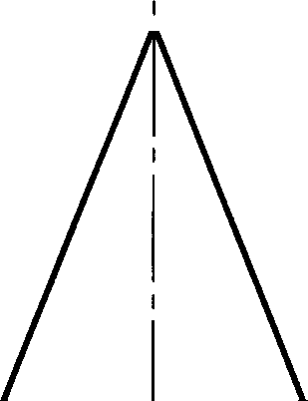

VP

HP

50

Problem 19 A rectangular pyramid of base-40mmx25mm and height50mm is placed centrally on a rectangular stab sides-100mmx60mm and thickness-20mm. Draw the isometric projection of the combination

##### Solution

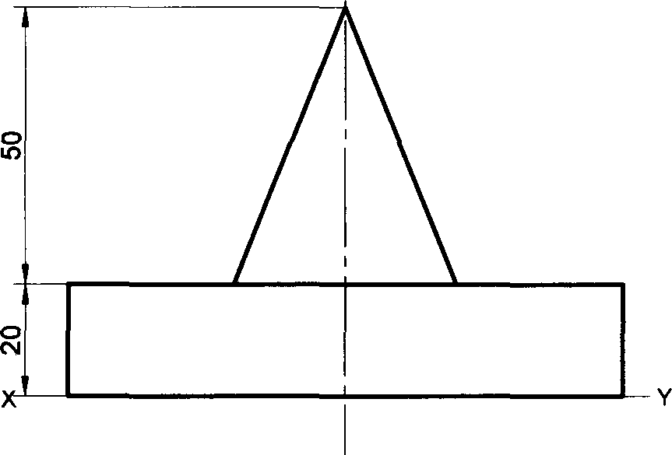

VP

HP

Problem 20 A square prism base side-40mm, height50mm is placed centrally on a cylindrical slab of diameter 100mm and thickness-30mm. Draw the isometric projection of the combination

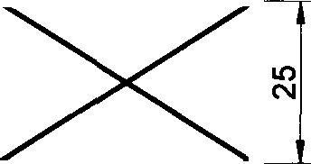

40

_ 100

# Solution

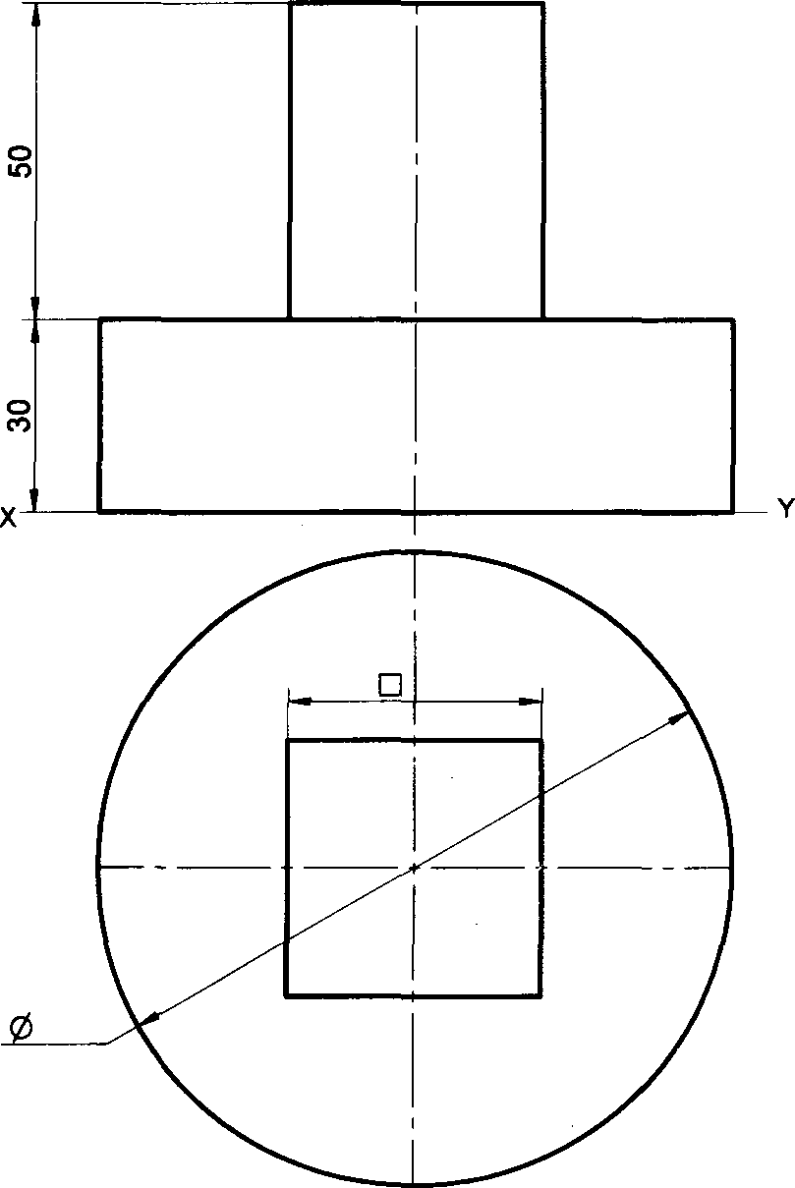

VP

HP

40

100

##### Problem 21 A square prism base side-40mm, height50mm is placed centrally on a rectangular slab sides-

100mmx60mm and thickness-20mm. Draw the isometric projection of the combination

##### Solution

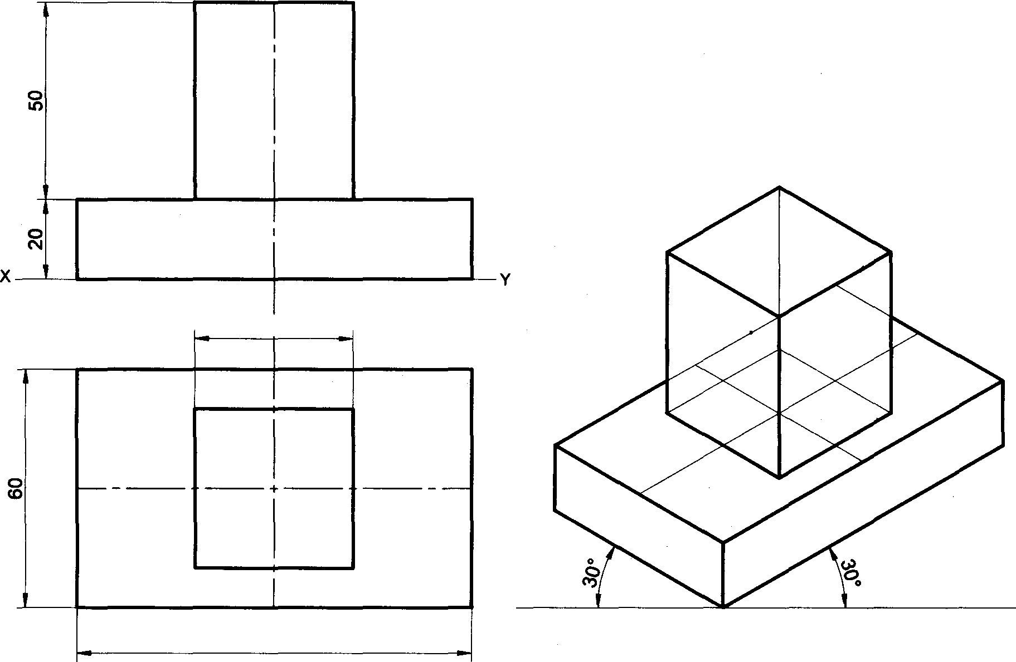

HP

40

100

Problem 22 A frustum of cone base diameter 50mm, top diameter 25mm and height50mm is placed centrally on a cylindrical slab of diameter 100mm and thickness-30mm. Draw the isometric projection of the combination Solution

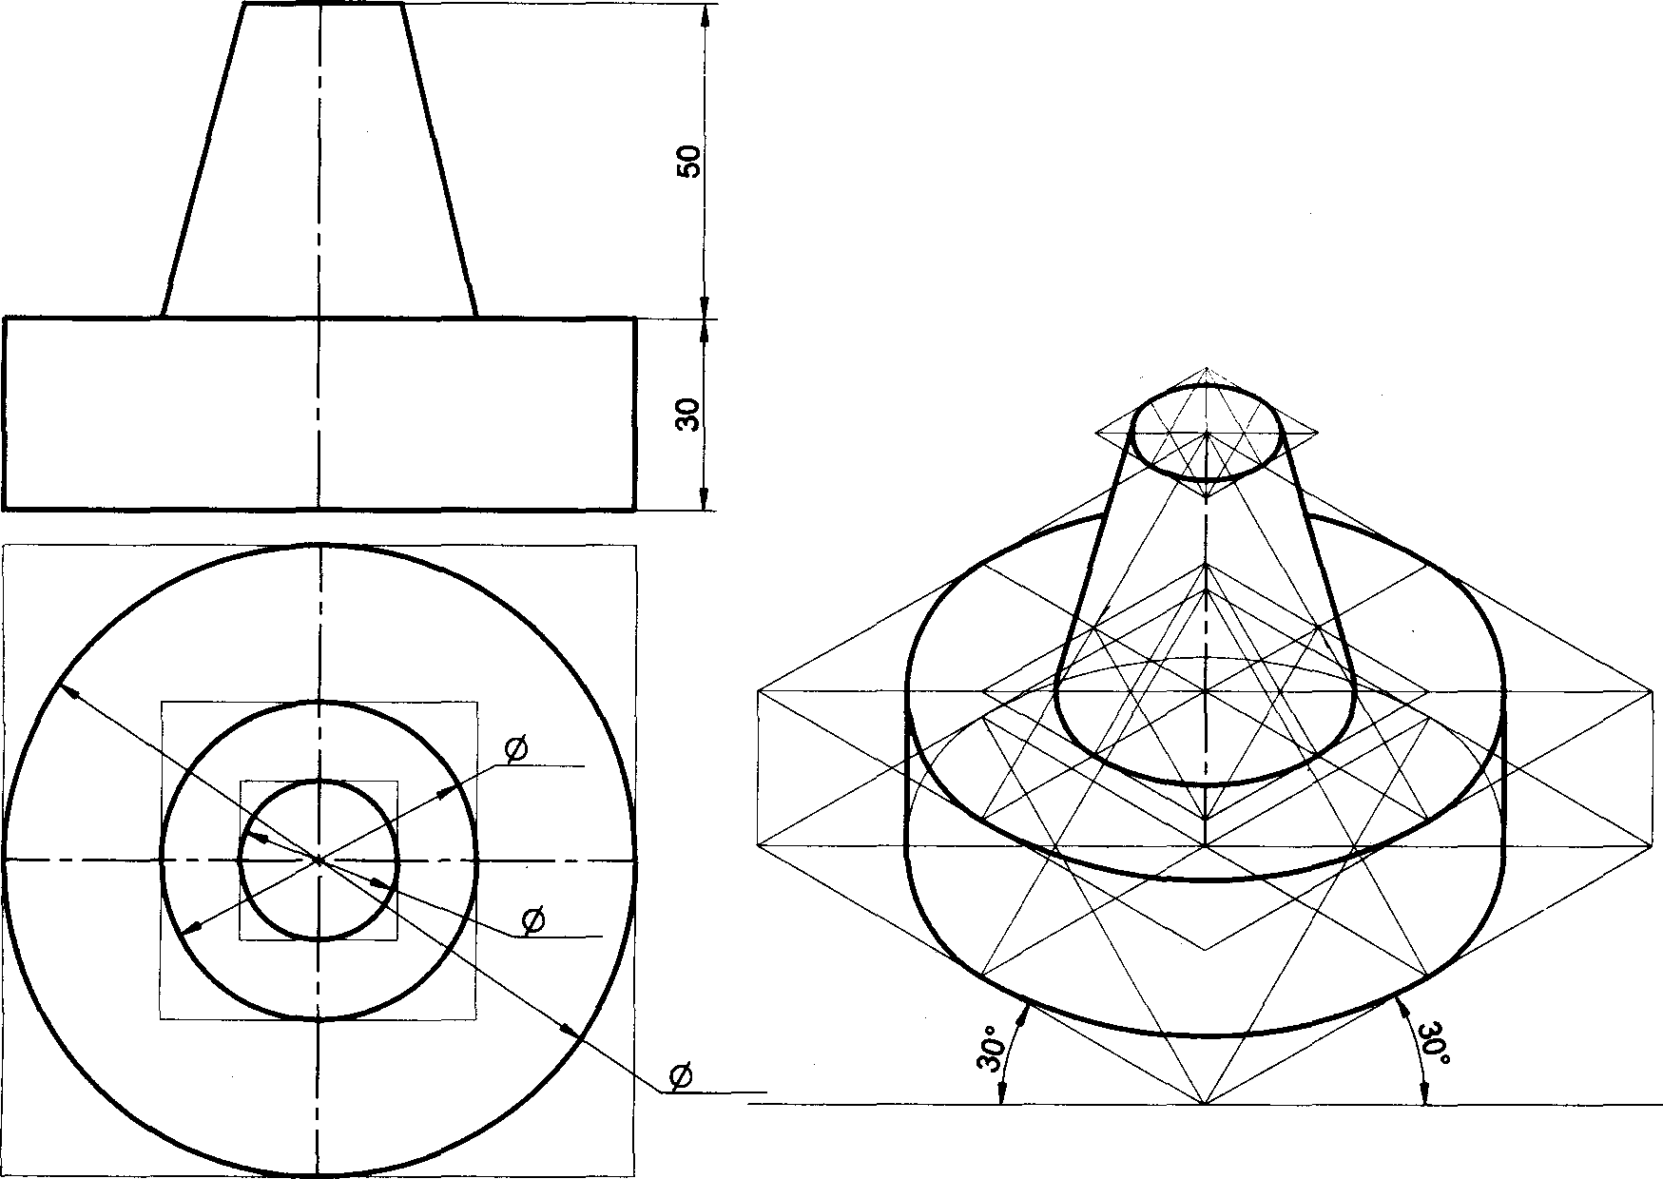

50

25

100

##### Problem 23 A frustum of cone base diameter 50mm, top diameter 25mm and height 50mm is placed centrally on a square slab side-80mm and thickness-30mm. Draw the isometric projection of the combination.

Solution

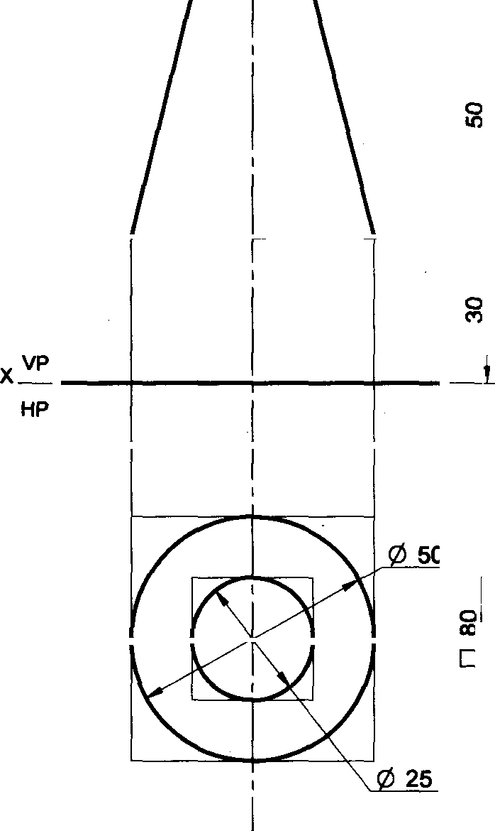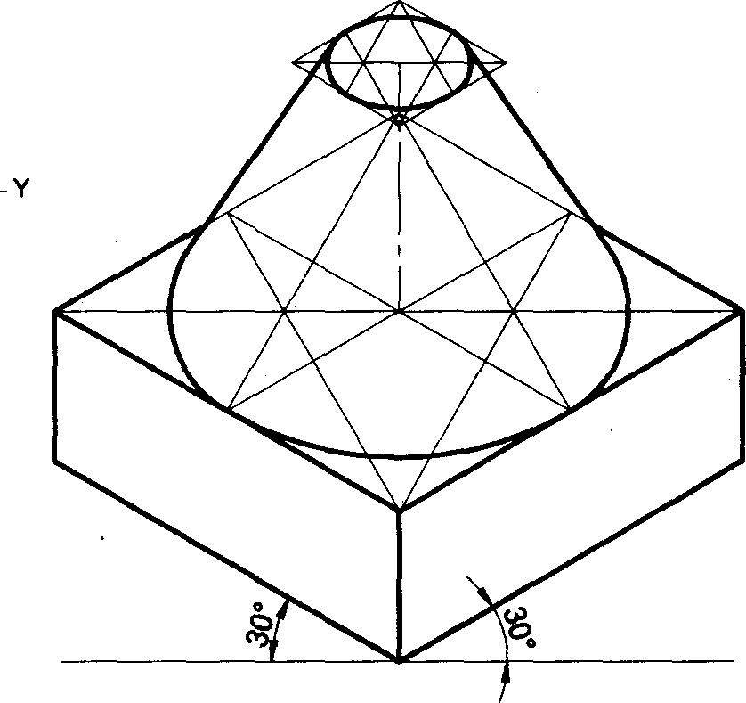

Problem 24 A frustum of cone base diameter 50mm, top diameter 25mm and height 50mm is placed centrally on the top face of a cylinder diameter 60mm and height 60mm. Draw the isometric projection of the combination

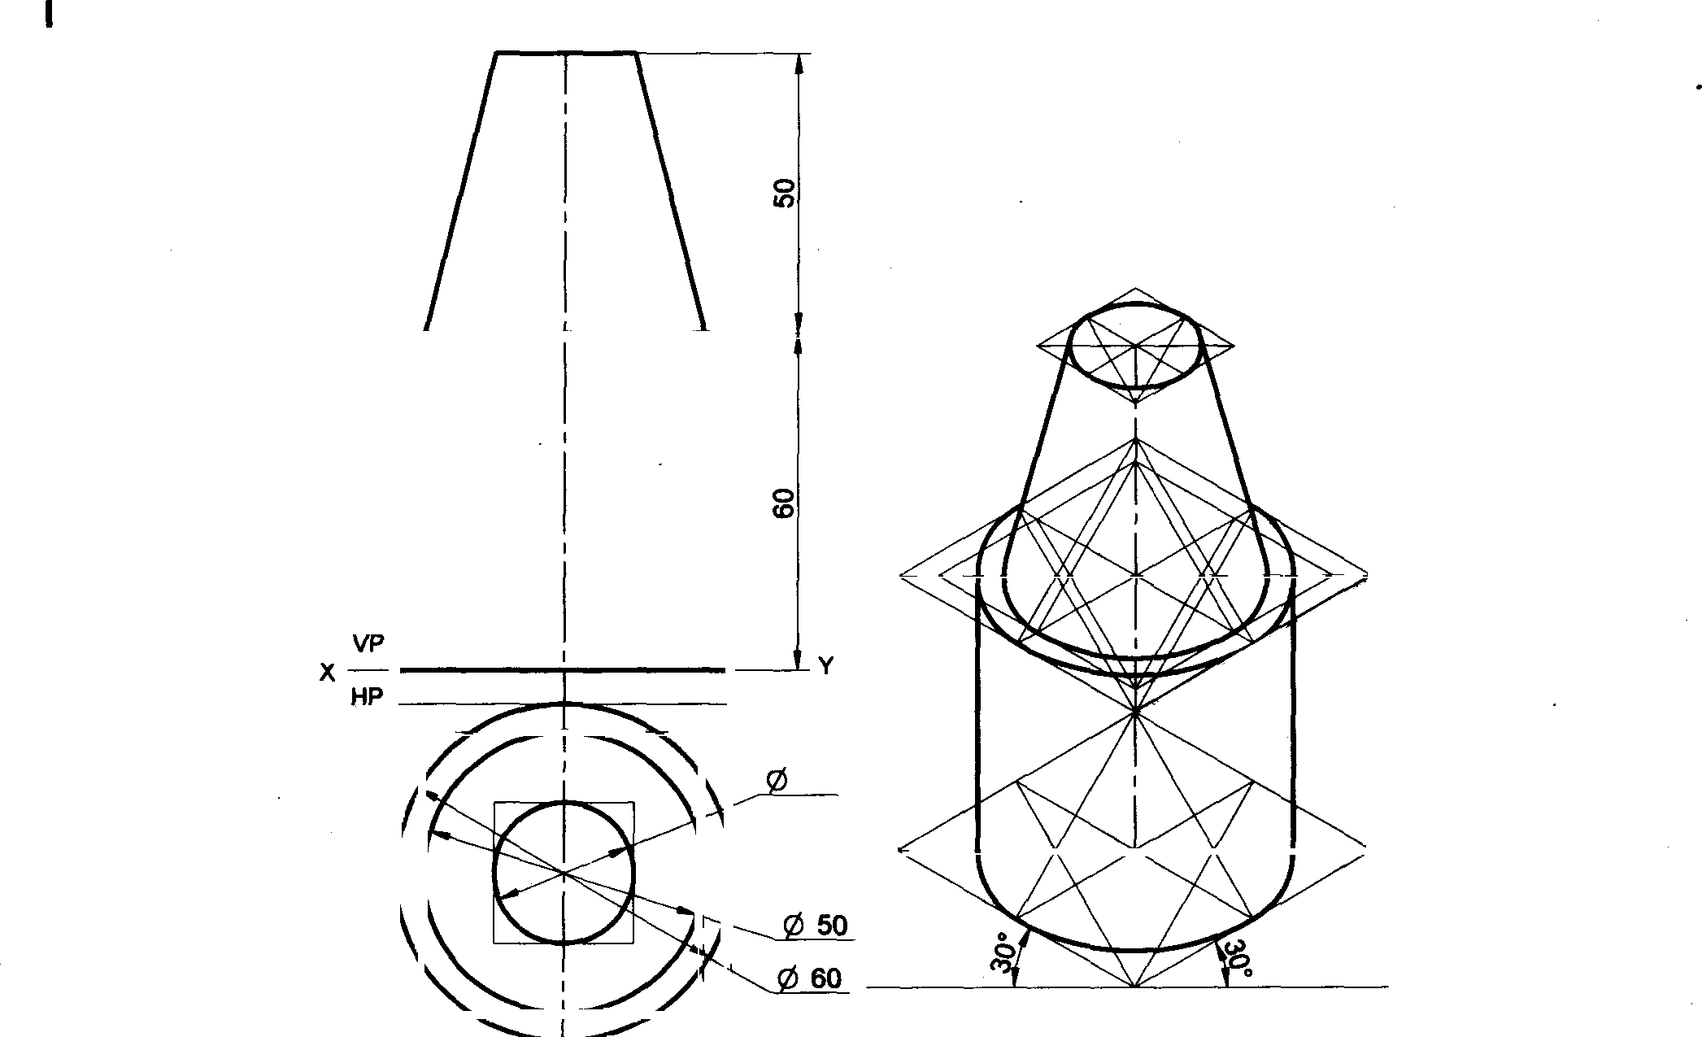

So utlon

5

##### **Problem 25 A** hemisphere diameter 50mm is resting on its curved surface centrally on the tep face of frustum of a rectangular pyramid base-80mmx60mm and top-60mmx40mm, height 55mm. Draw the isometric projection of the combination

**Solution**

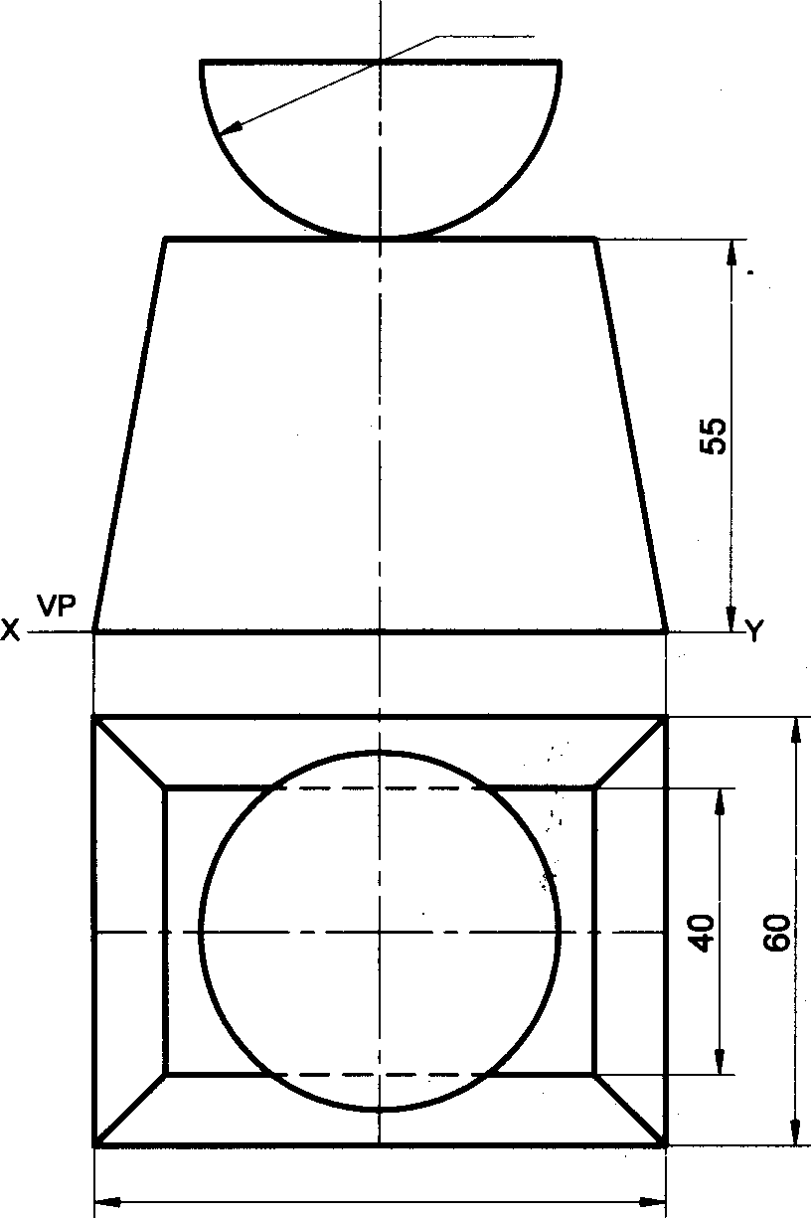

R 25

HP

80

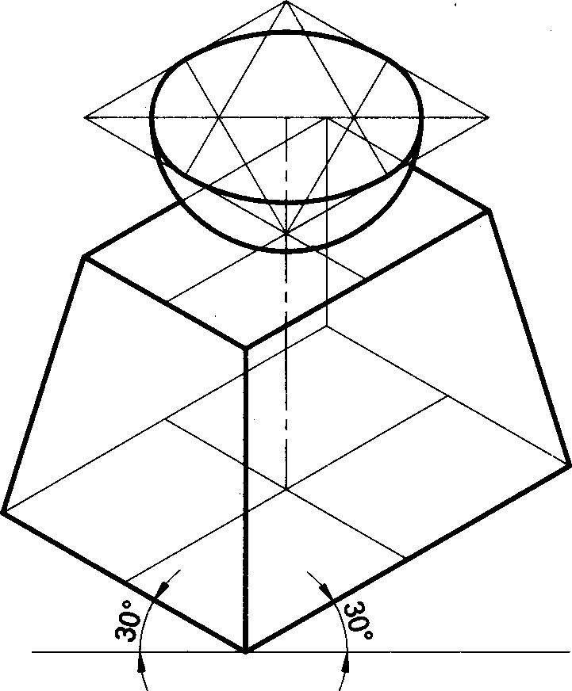

##### Problem 26 A hemisphere diameter 70mm is placed on the ground on its curved surface. A cone base diameter 70mm and height 70mm is placed centrally on it. Draw the isometric projection of the combination

**Solution**

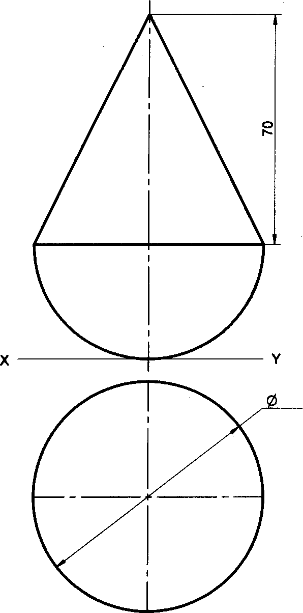

VP

HP

70

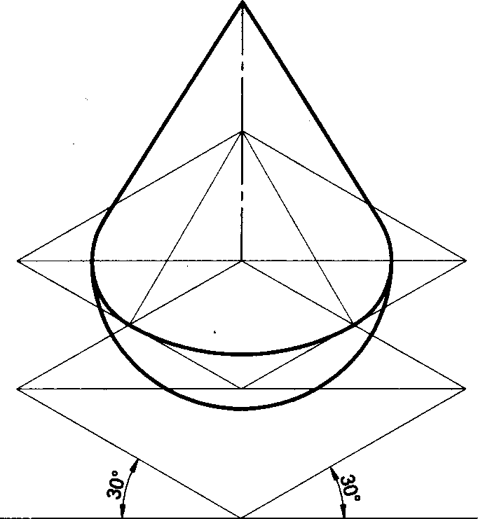

##### Problem 27 Following figure shows the front and side views of solid. Draw the lsometric projection of the

solid.

Solution

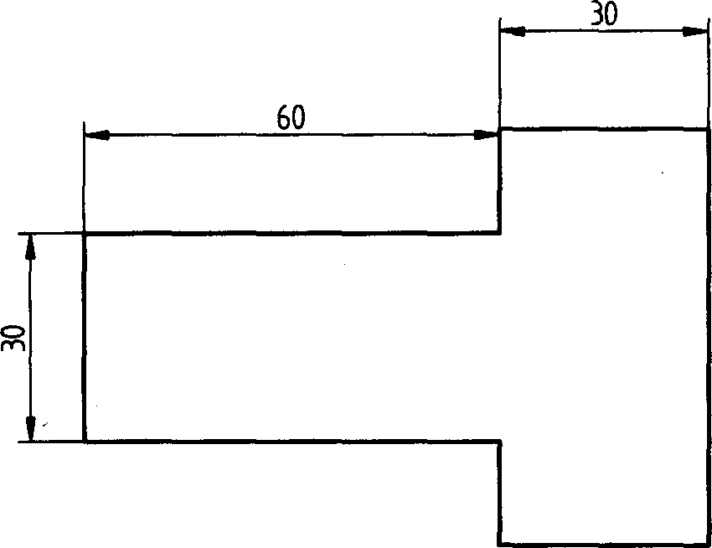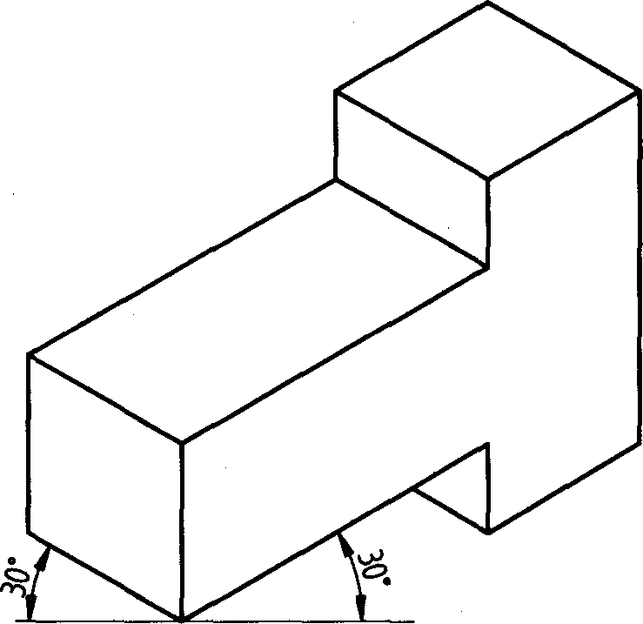

30

Problem 28 Following figure shows the front and side views of solid. Draw the lsometric projection of the

solid.

#### Solution

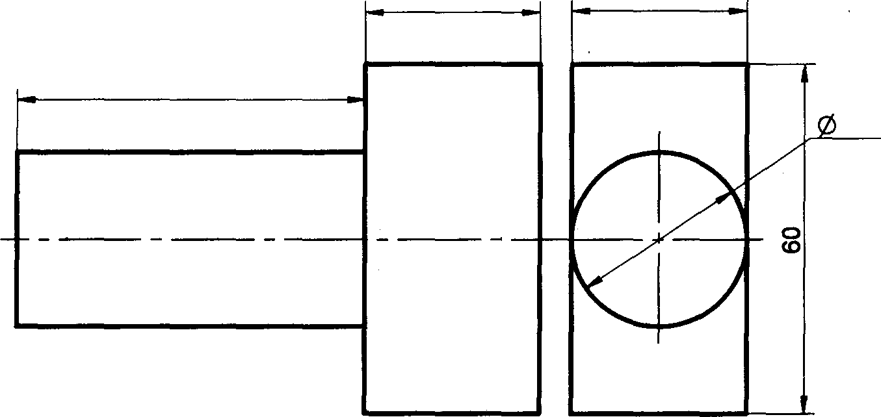

30

30

60

30

Problem 29 Following figure shows the front and side views of solid. Draw the lsometric projection of the solid.

# Solution

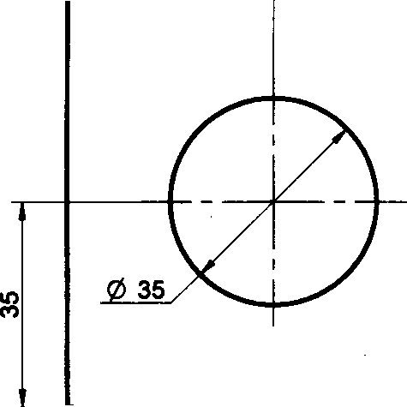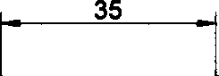

70

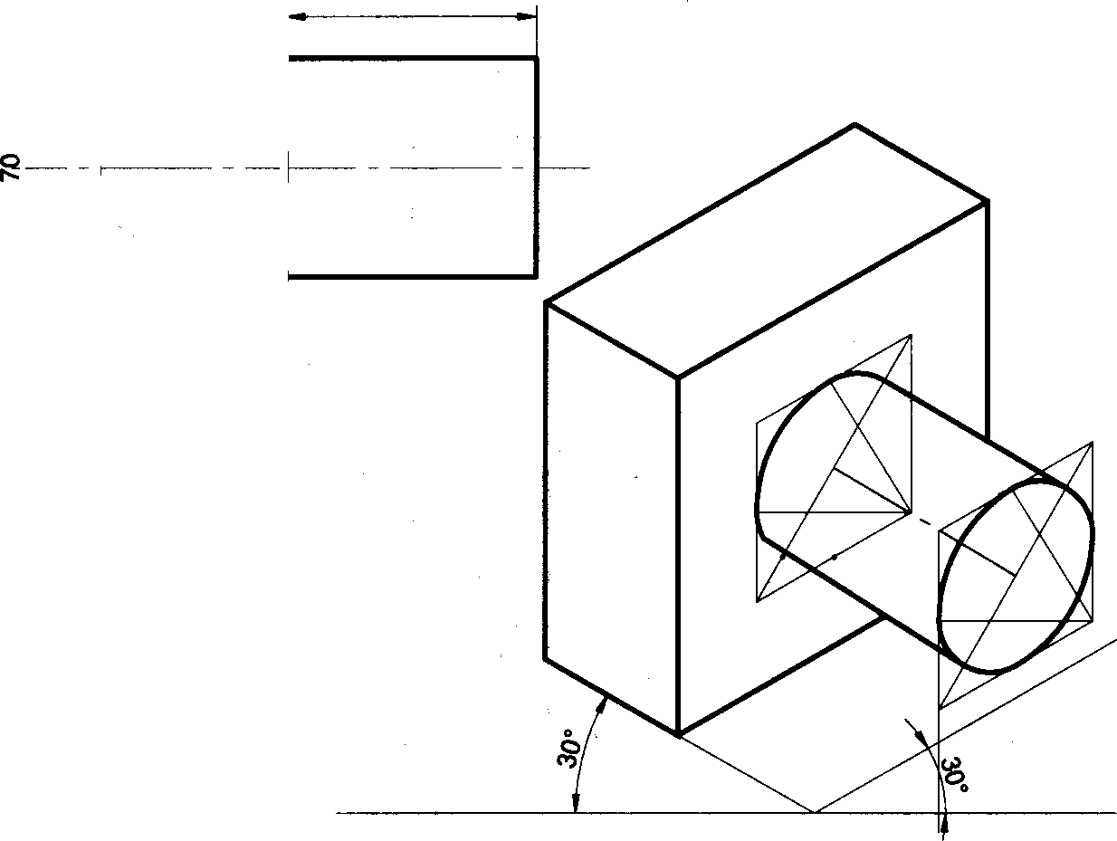

40

Problem 30 Following figure shows the front and top views of solid. Draw the Isometric projection of the solid.

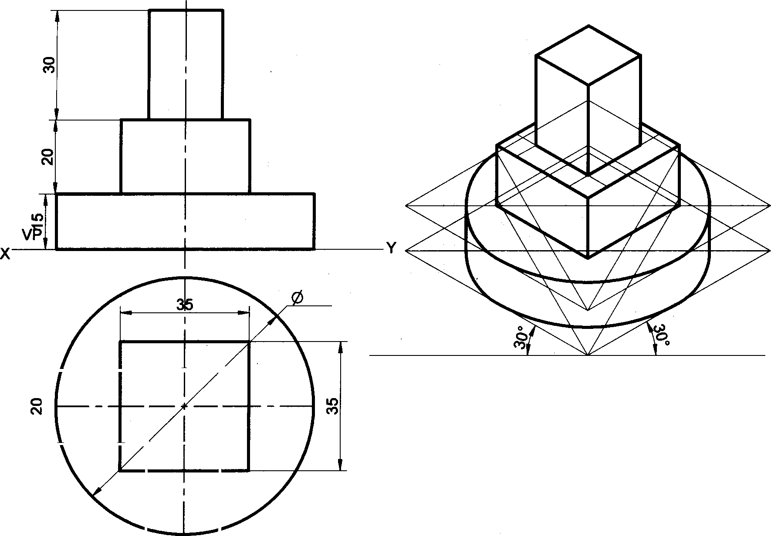

Solution

HP

70

20

Problem 31 Following figure shows the front and top views of solid. Draw the Isometric projection of the

solid.

### Solution

VP HP

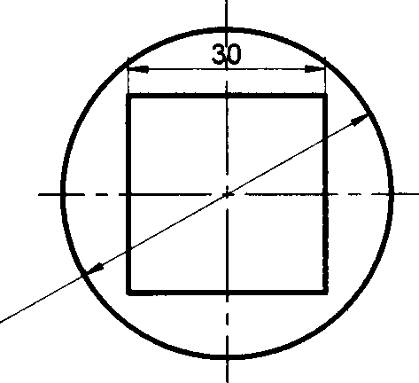

@ 50

0 70

Problem 32 Following figure shows the front and side views of solid. Draw the Isometric projection of the solid.

# Solution

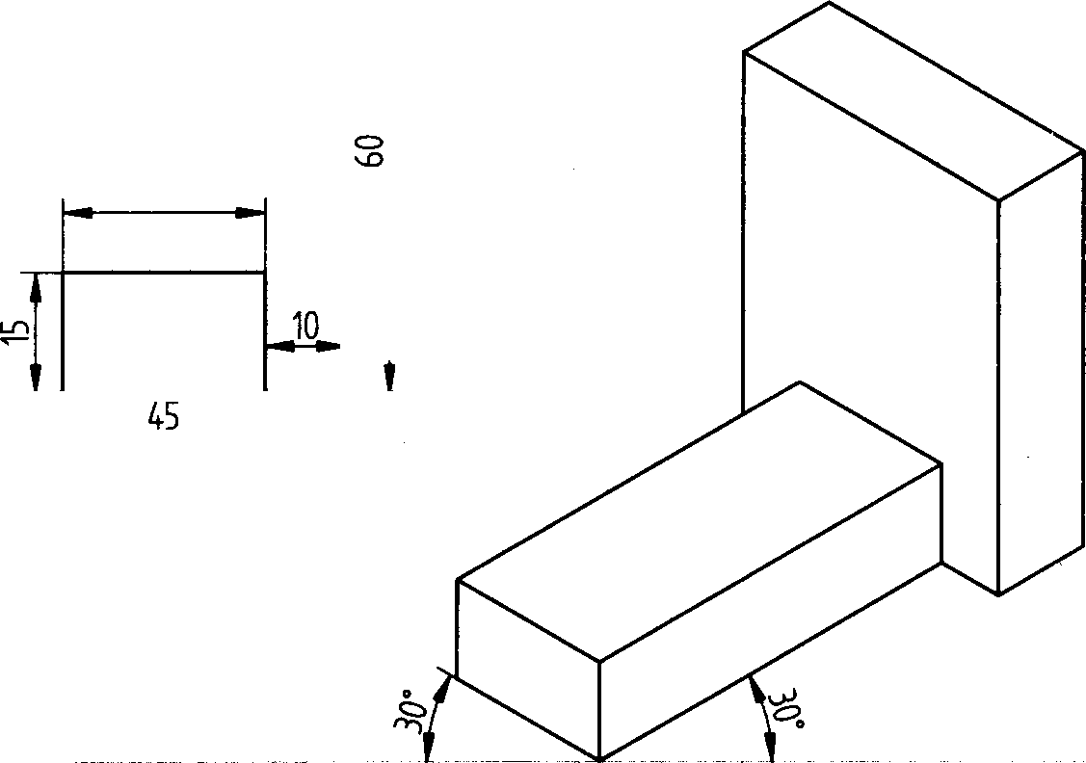

25

##### Problem 33 A sphere diameter 60mm is placed centrally on the top face of a square prism side-60mm and height

70mm. Draw the isometric projection of the combination

##### Solution

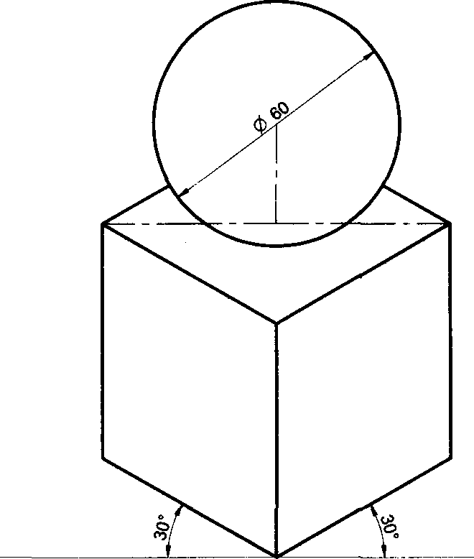

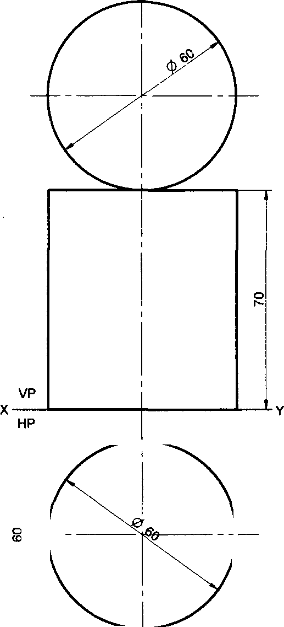

Problem 34 A sphere f60mm is placed centrally on the top face of a hexagonal prism side-35mm and height

50mm. Draw the isometric projection of the combination

##### Solution

Problem 35 A pentagonal pyramid base side-25mm and height 65mm is placed centrally on a rectangular slab 100mmx60mm and 20mm-thick. Draw the isometric projection of the combination.

##### Solution

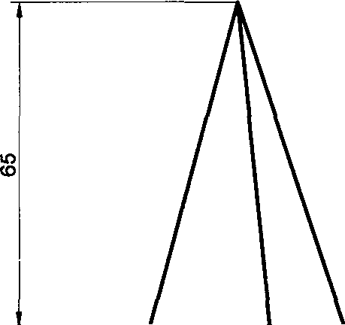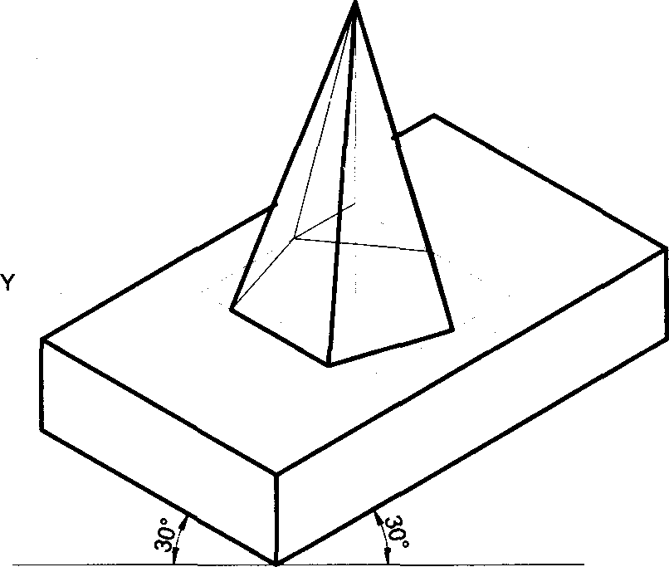

VP

HP

23 78

30 76

100

Problem 36 A cone base diameter 45mm and height 65mm is placed centrally on the top face of a pentagonal prism side-45mm and height 35mm. Draw the isometric projection of the combination

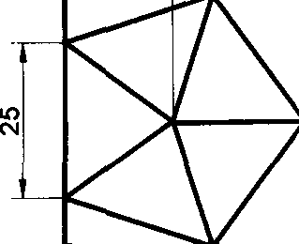

##### Solution

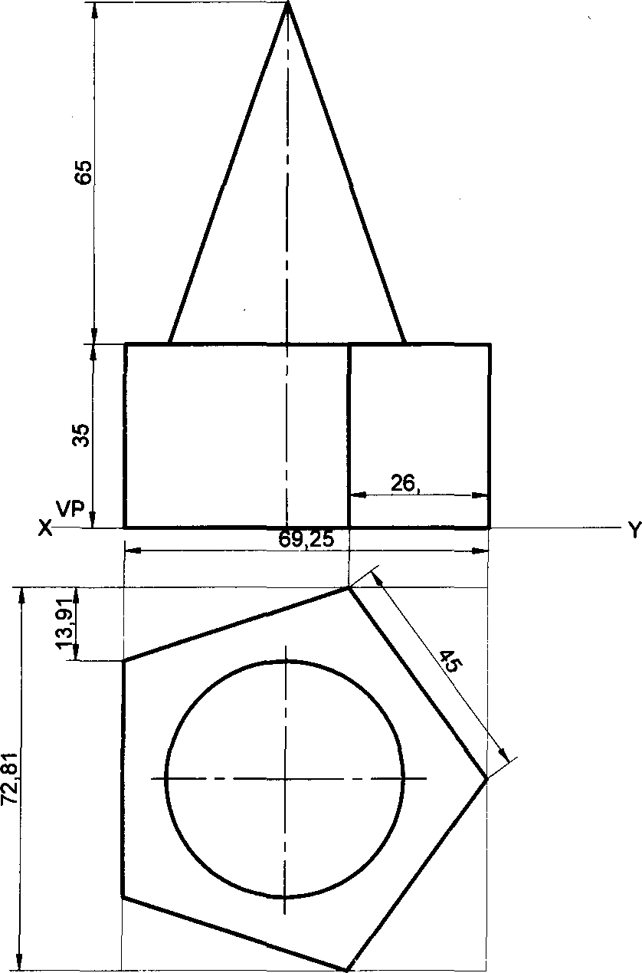

45

HP

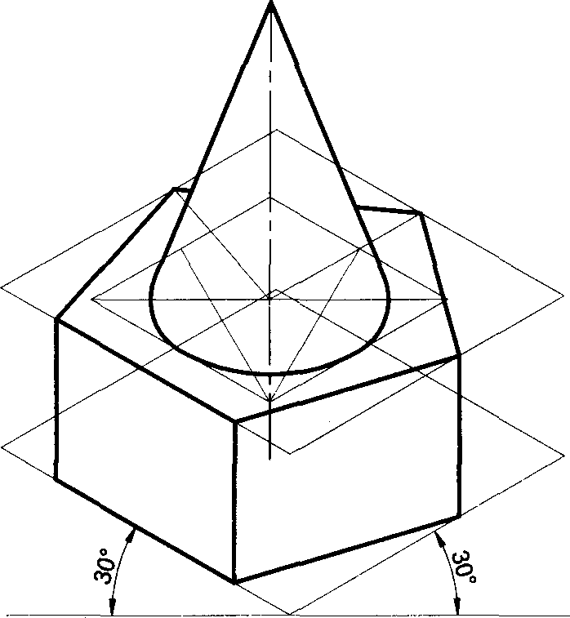

Problem 37 A sphere diameter 40mm is placed centrally on the flat face of a hemisphere diameter 60mm. Draw the

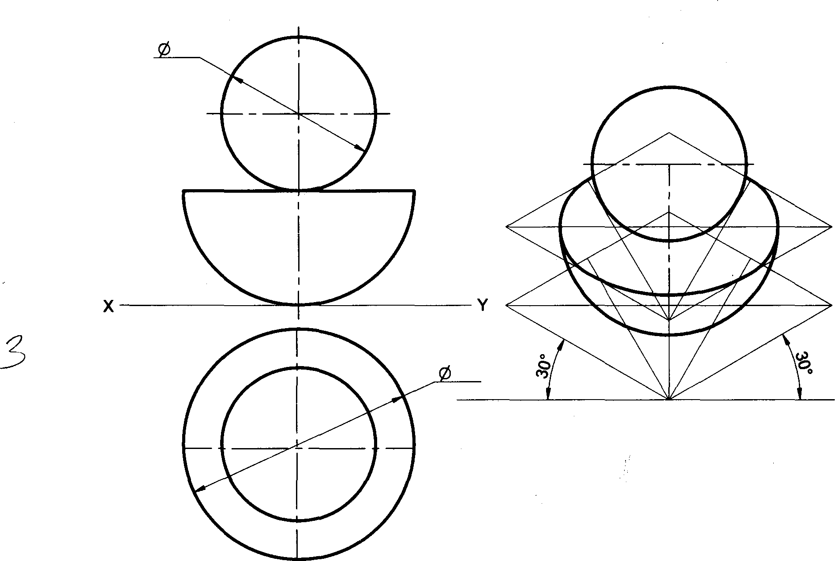

isometric projection of the combination

Solution

40

VP

HP

60

Problem 38 A cone of base diameter 60mm, top diameter 40mm and height 50mm is placed centrally on frustum of a square pyramid base side-100mm top face side-60mm and height 20mm. Draw the isometric projection of the com- bination

##### Solution

HP

60

Problem 39 A frustum of a square pyramid base side-40mm, top face side-20mm and height 40mm is placed centrally on frustum of a cone base diameter 80mm, top diameter 60mm and height 20mm. Draw the isometric projection of the combination

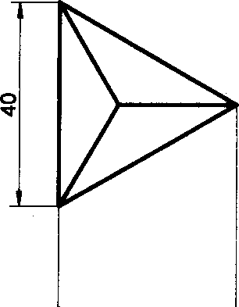

28 45 1 34 64

*0* 80

##### Solution

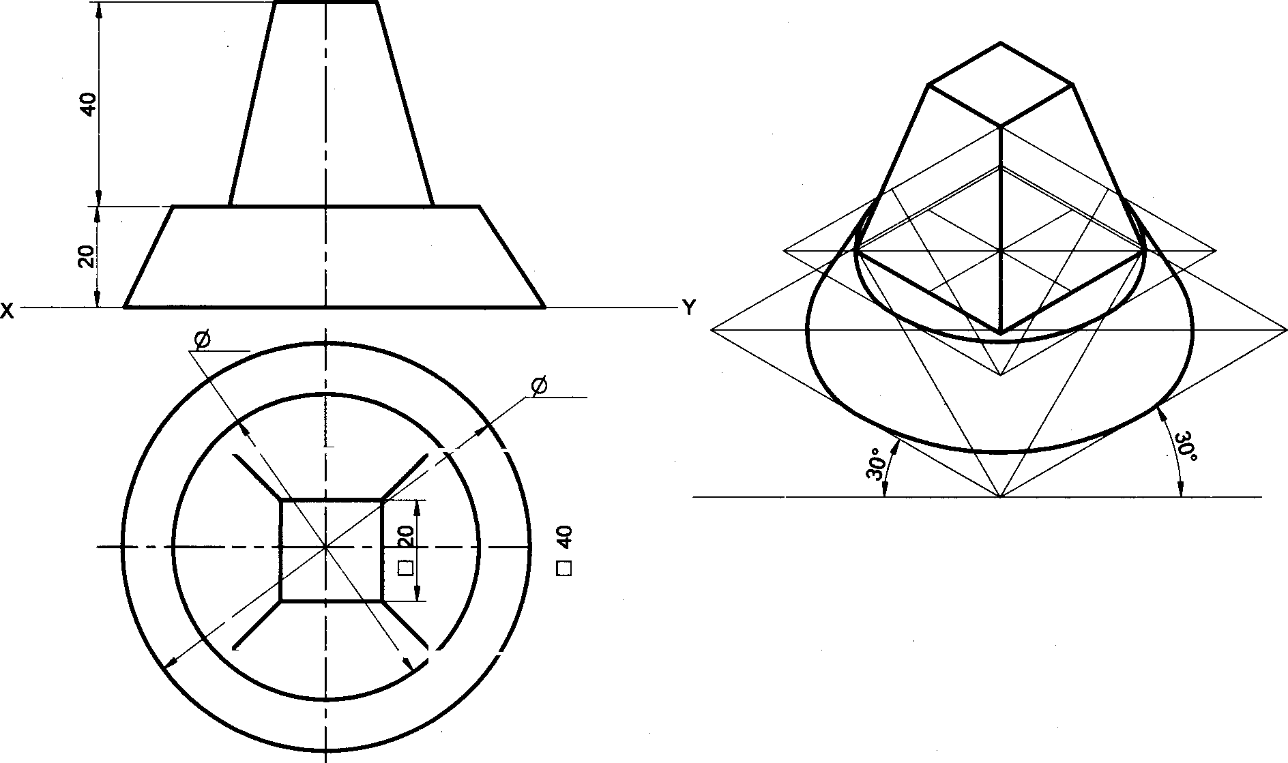

VP

HP

60

80

Problem 40 A triangular pyramid base side-40mm and height 50mm is placed centrally on a square slab side-

80mm and 20mm-thick. Draw the isometric projection of the combination

##### Solution

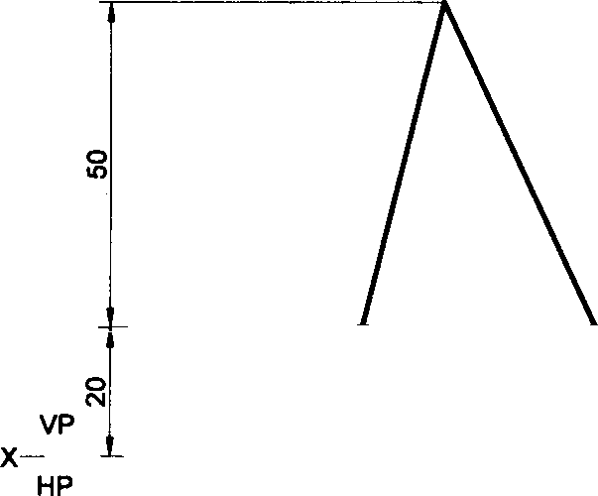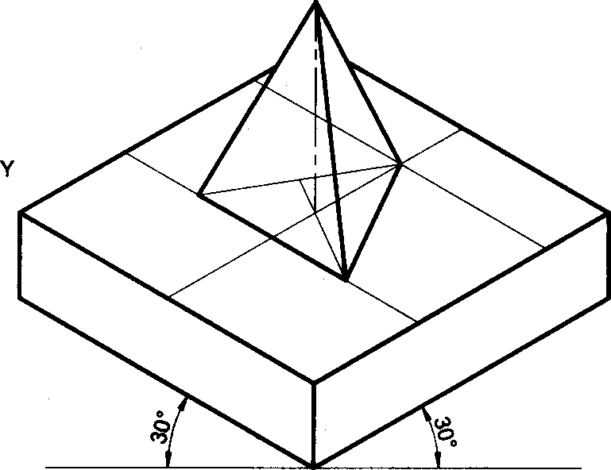

Problem 41 A cube of side-25mm is resting centrally on a rectangular slab 100mmx4Omm and 30rnm thick. Draw the isometric projection of the combination

##### Solution



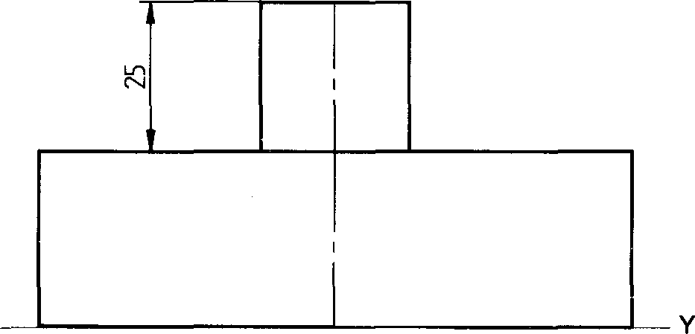

VP

HP

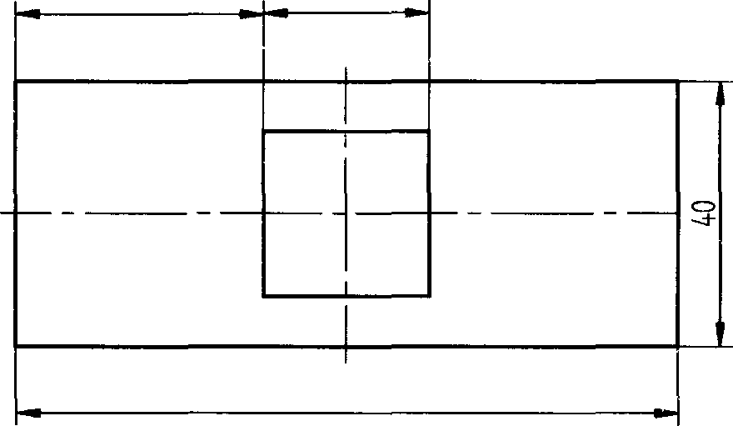

37,5

TOO

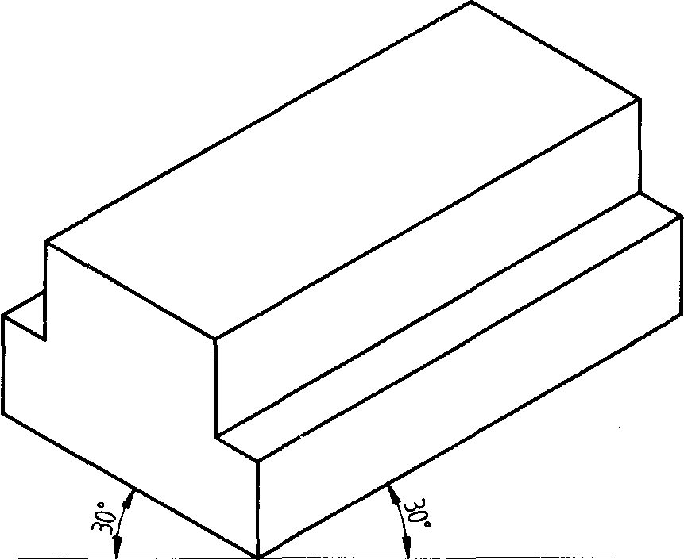Problem 42 Two rectangular plates are placed centrally with dimensions (Ixbxh)100mmx60mmx20mm and 1OOmmx40mmx20mm such that longer edges are parallel. Draw the isometric projection of the combination Solution

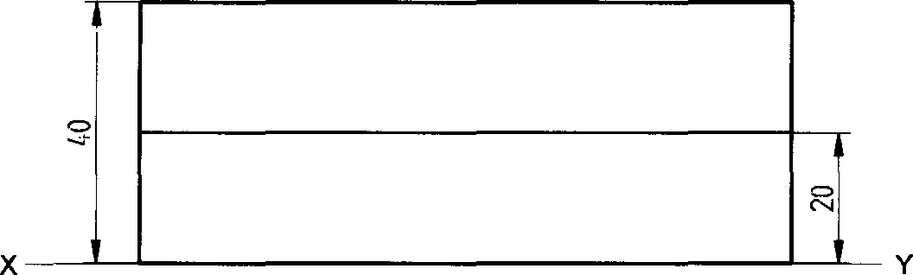

HP

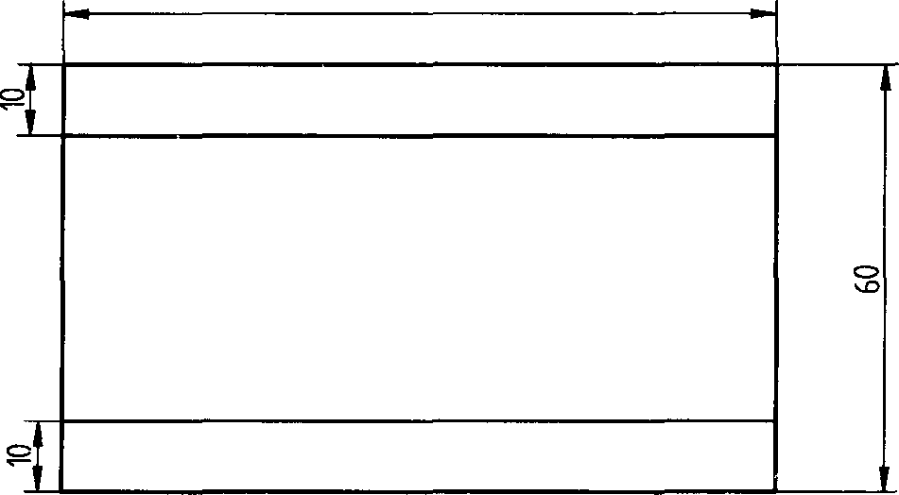

100

17’1

Problem 43 A cube of side-40mm is resting centrally on a hexagonal prism base side-40mm and height 50mm, such that one of the base sides of the cube is parallel to one of the sides of the top face of the prism. Draw the isometric projection of the combination.

20

##### Solution

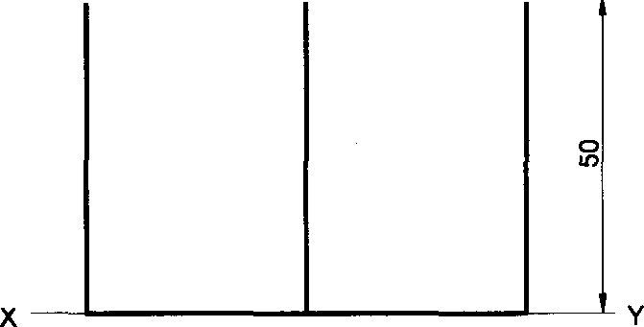

VP

Problem 44 A triangular prism base side-30mm and length-70mm is resting on its rectangular face on top of a square slab side-7omm and 25mm-thick. Draw the isometric projection of the combination

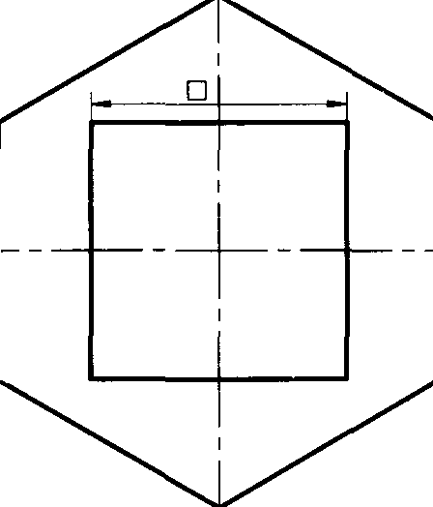

40

40

80

##### Solution

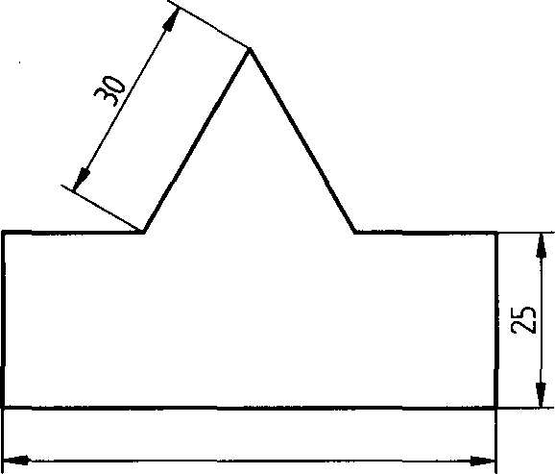

70

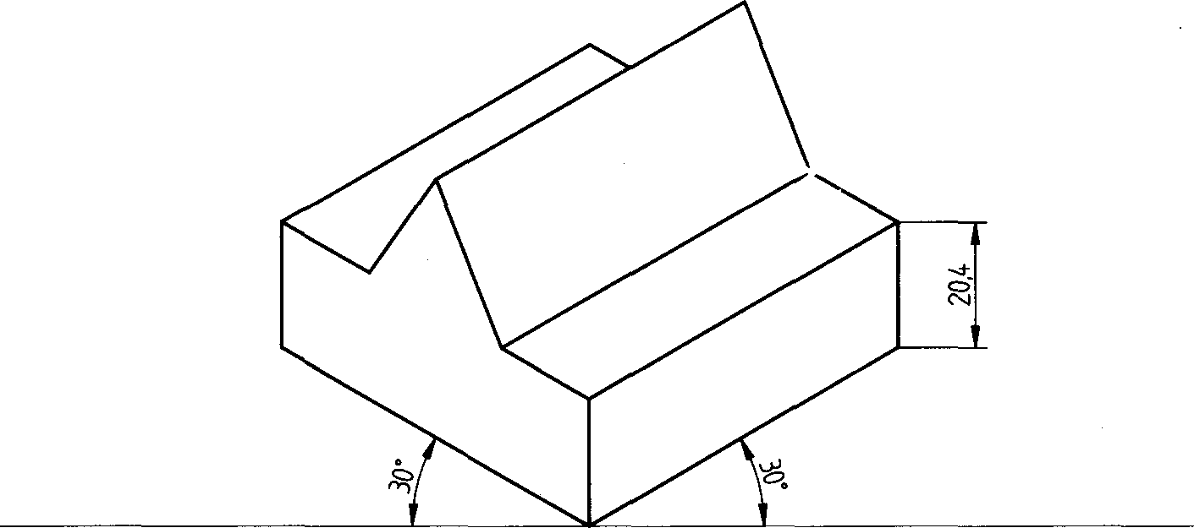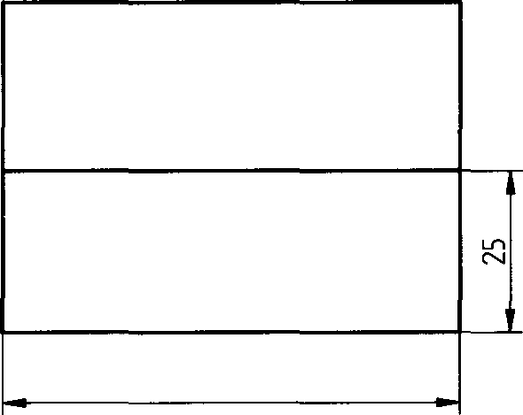

70

Problem 45 A square prism of base side-3omm and length-70mm, is resting on its rectangular face on top of a square slab side -70mm and 25mm-thick. Draw the isometric projection of the combination

Solution x.

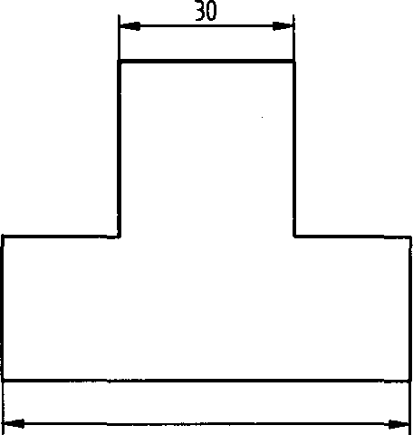

70

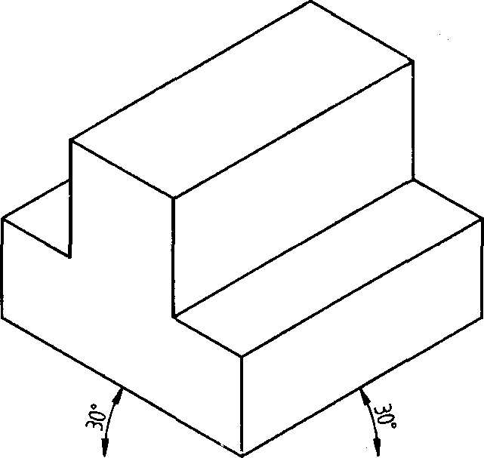

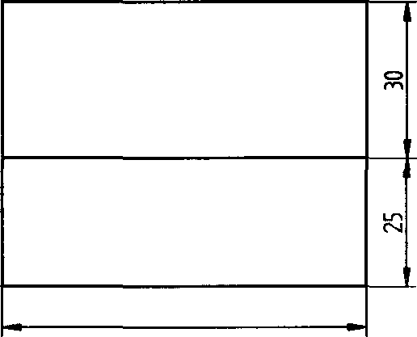

70

Problem 46 Three rectangular slabs (lxbxh) 1O0mmx60mmx20mm 1O0mmx40mmx2Omm and 10Ommx20mmx2Omm are placed one above the other in the ascending order of their width-b, such that their longer axes are co-planar. Draw the isometric projection of the combination

##### Solution

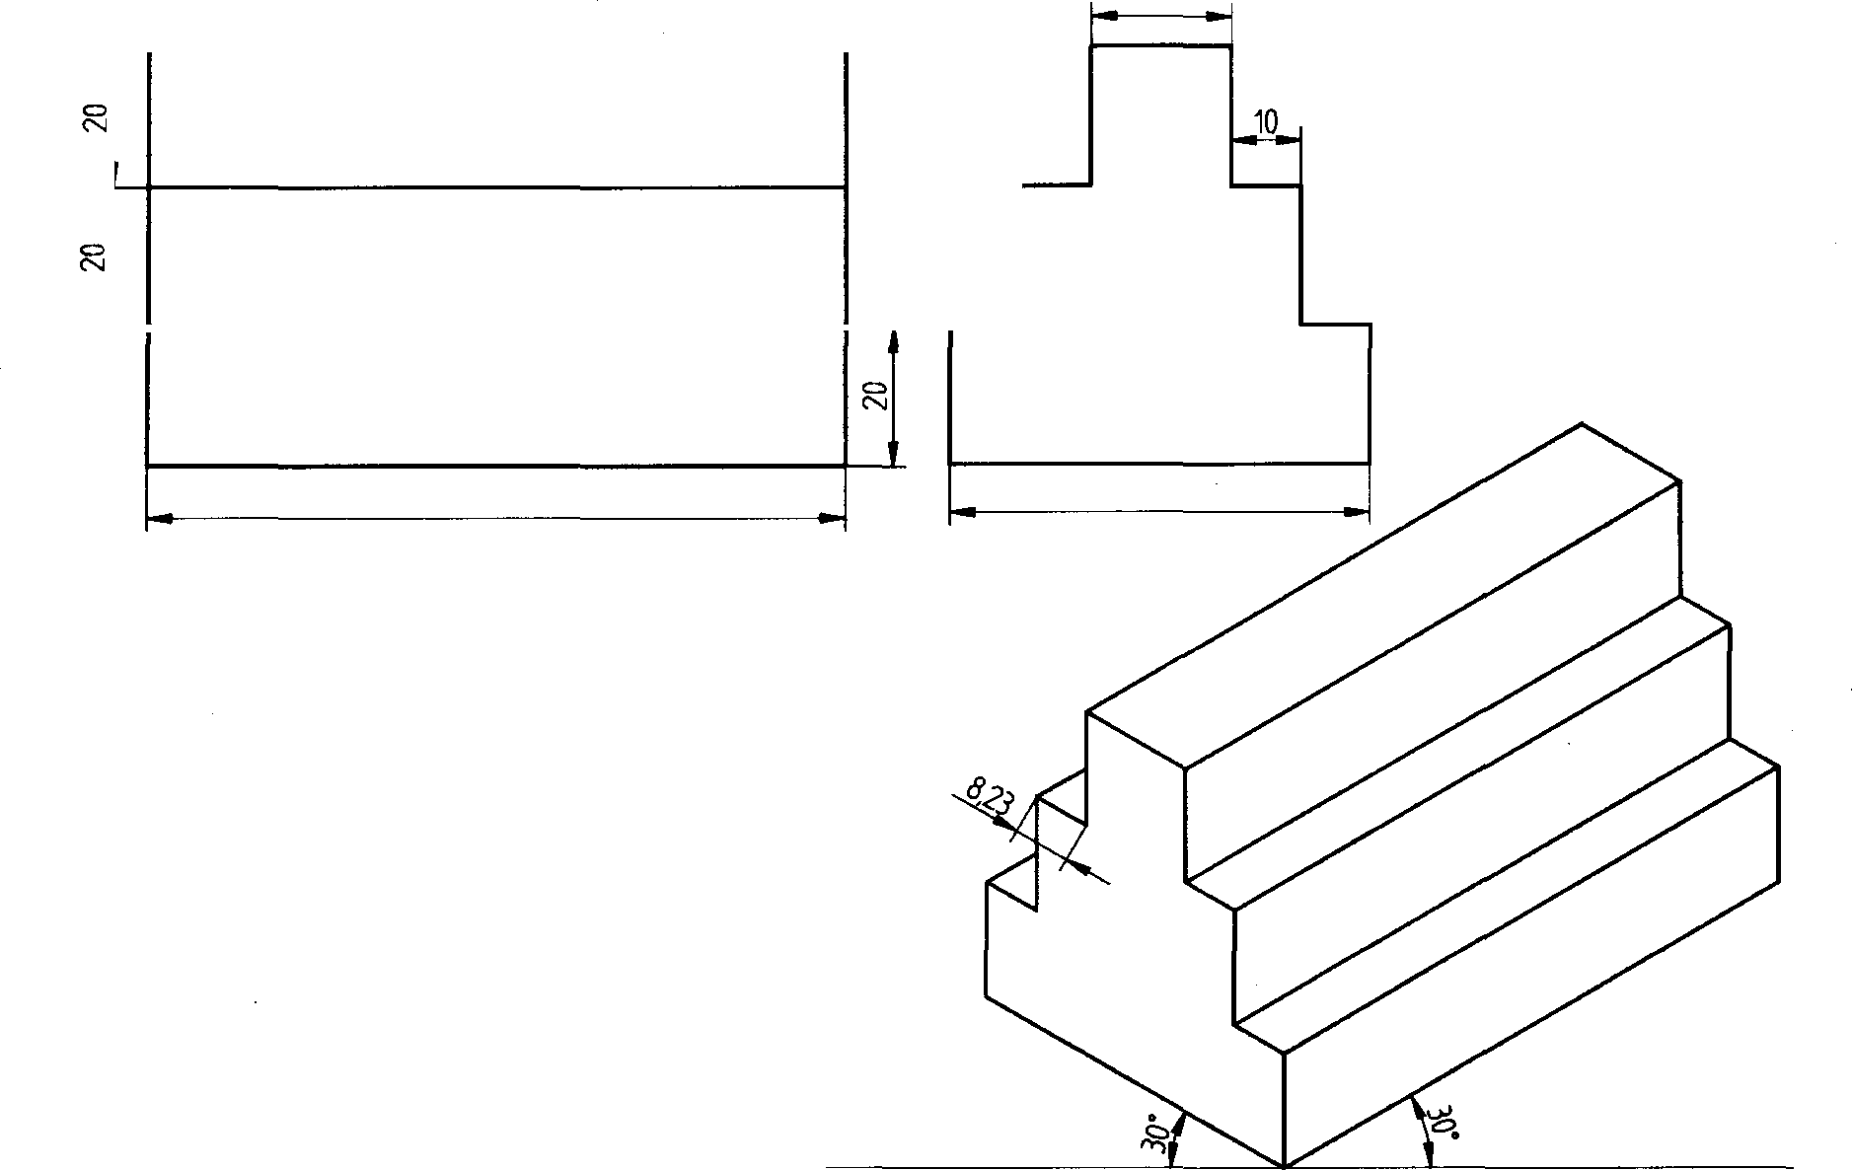

20

100 60

Problem 47 Three cubes of sides 60mm, 40mm and 20mm are placed centrally one above the other in the ascending order of their side. Draw the isometric projection of the combination

Solution

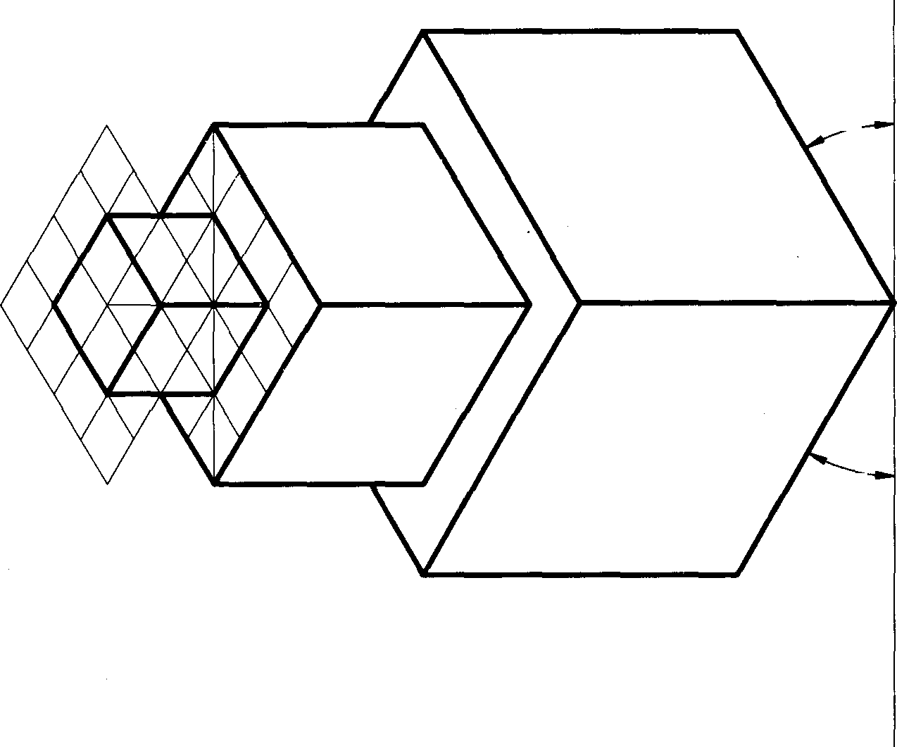

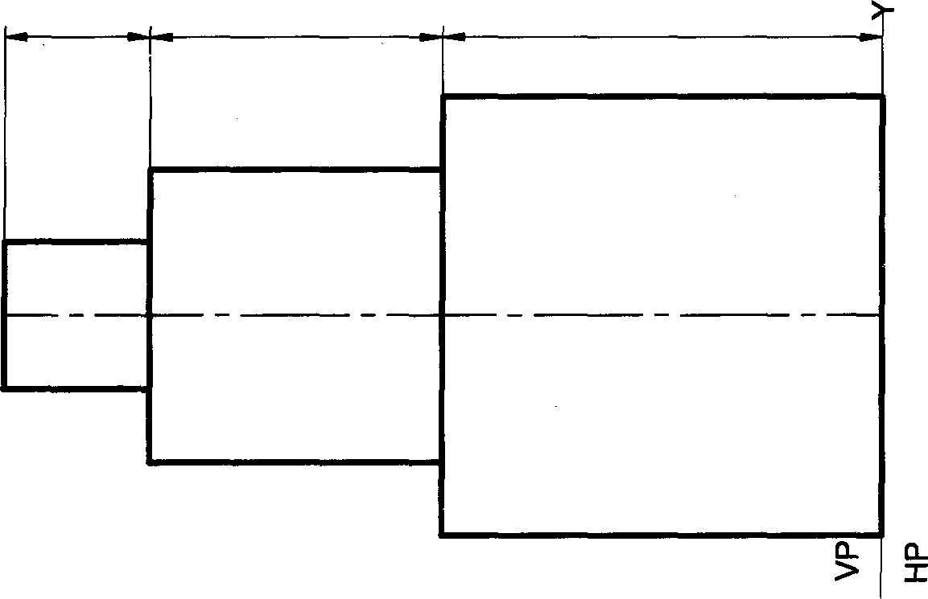

0Z

0#

09

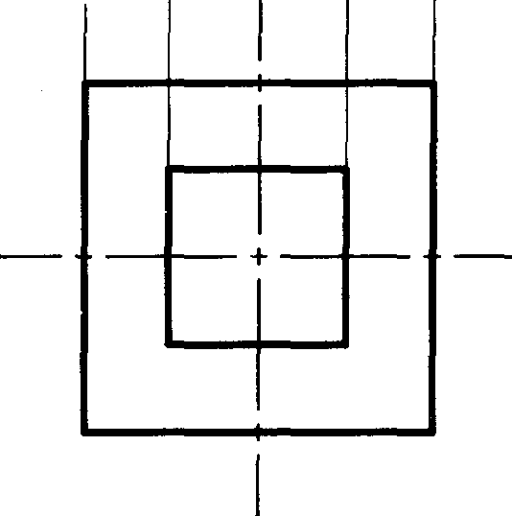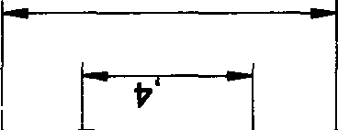

09

0S

0Z

174

Problem 48 A cone of base diameter 50mm and height 60mm is placed centrally on an equilateral triangular prism of side-100mm and 20mm thick Draw the isometric projection of the combination

VP

HP

#### Solution

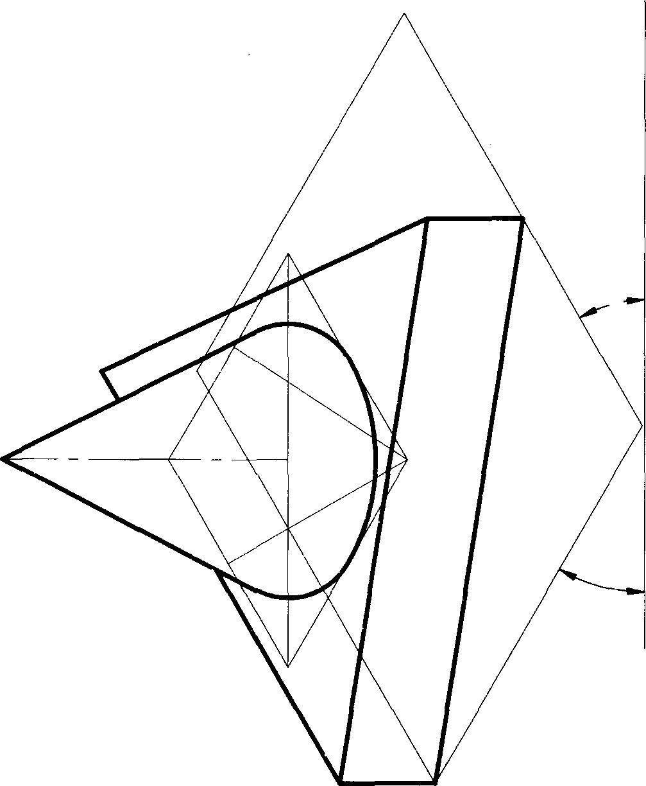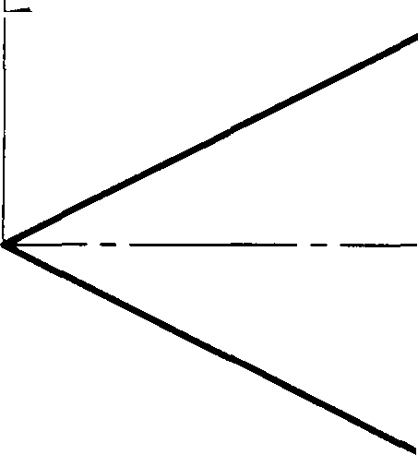

OS

OZ

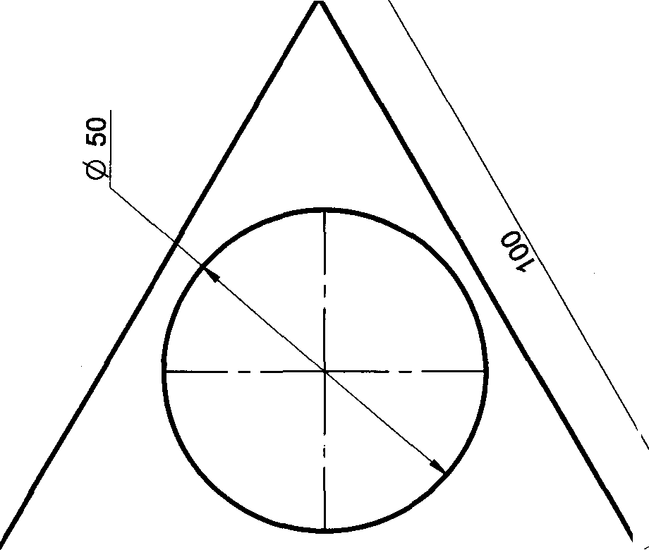

Problem 49 A square prism side-40mm and height 70mm has a full depth co-axial square hole side-20mm, such that edges of both the squares are parallel. Draw the isometric projection of the combination

# Solution

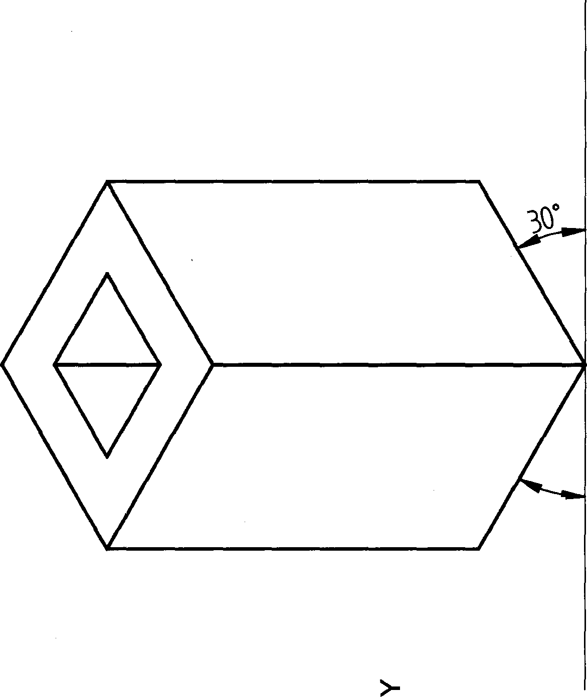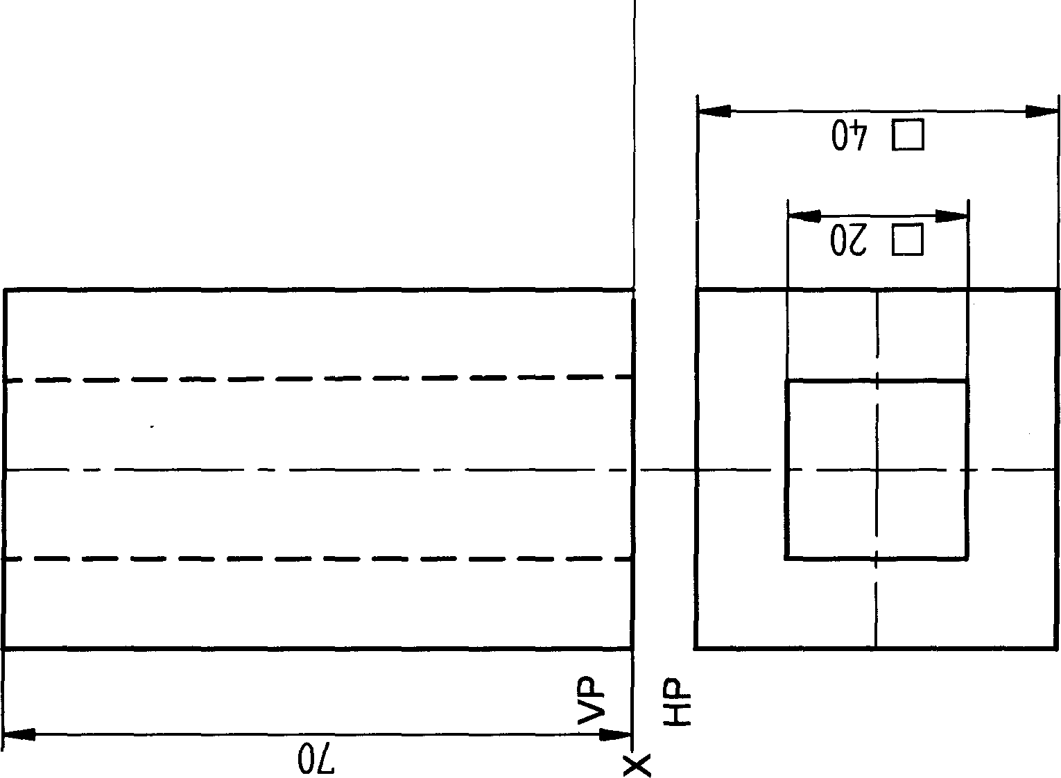

176

Problem 50 A rectangular slab base-100mmx80mm and height 30mm has a full depth co-axial square hole side- 40mm, such that one of the sides of the square is parallel to one of the sides of the rectangle. Draw the isometric projection of the combination

VP

HP

#### Solution

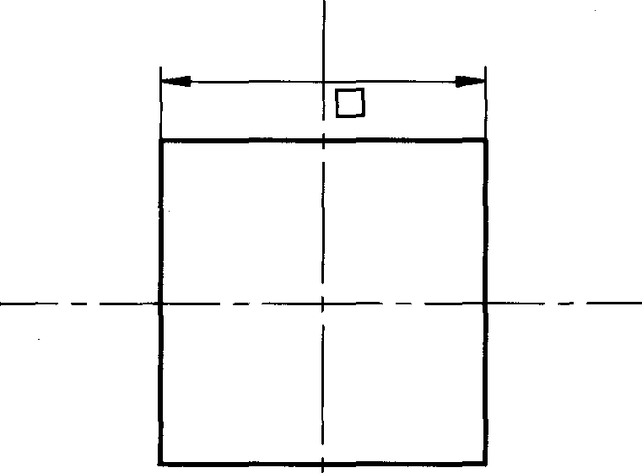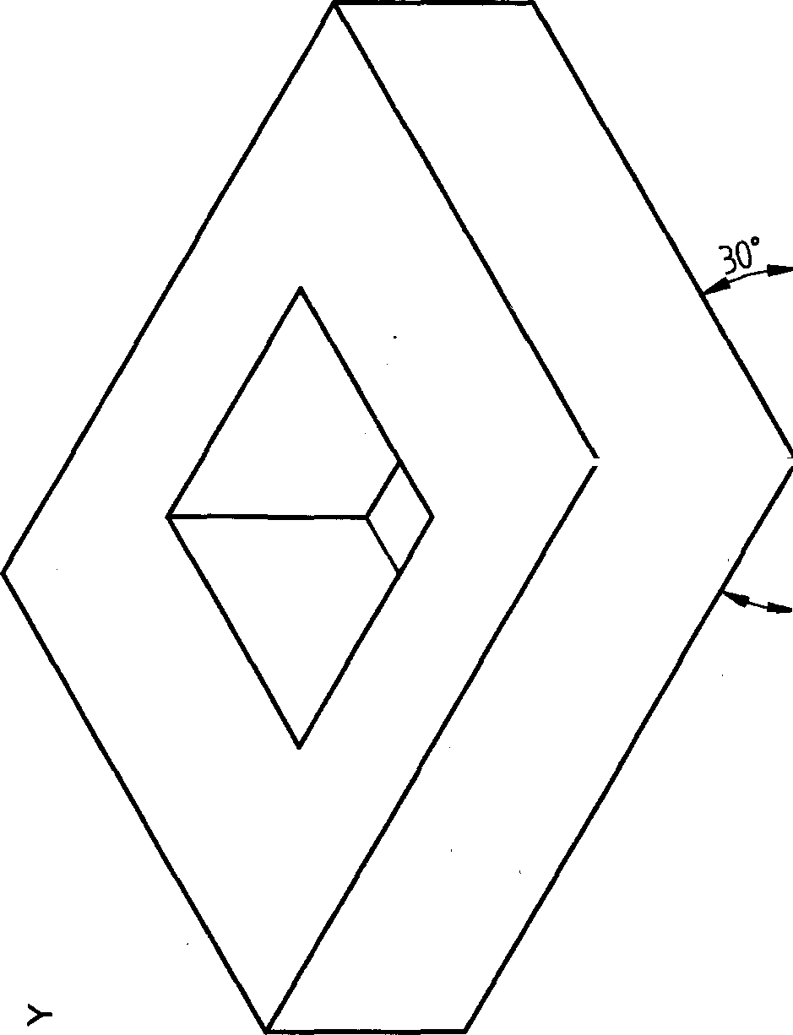

01

08

OE